VisionServe Alliance

2020 Executive Leadership Conference Sponsor & Exhibitor Prospectus
Join us for the 2020 VisionServe Alliance Executive Leadership Conference Nov. 1 – 5, 2020.
First and foremost, all of us at VisionServe Alliance hope that you and your family are doing as well as possible during the COVID-19 medical crisis.
That is why VSA’s Board of Directors made the early decision to transition the 2020 ELC to an immersive and interactive virtual meeting. This year’s theme is Still Stronger Together and working together is more important than ever during this pandemic.
We understand that many of you, our partner companies, have experienced disruption to your businesses and budgets, but as we all know, serving people with vision issues does not wait. Statistics show that the number of people with blindness and/or low vision is increasing, and they have an urgent need of the most up-to-date technology and resources. That is why your participation in the ELC is needed this year more than ever.
VSA has invested in a versatile and robust online platform for the meeting that will include video product demonstrations, live chat features, networking lounges, and lead-generating analytics available to all exhibitors. One important aspect is that while our meeting will be live and online from November 1 – 5, the platform will become live 30 days BEFORE the event and remain live for 60 days afterwards, giving your company maximum exposure to hundreds of leaders and professionals from all over the world who will be active.
We understand that this new format will be different than past meetings, and VSA will provide regular exhibitor updates and how-to’s in the weeks leading up to the meeting to keep you informed of all the exciting features and answer any of your questions.
I encourage you to join us as a sponsor and exhibitor at VSA’s 2020 Executive Leadership Conference annual event for leaders working in the field of blindness and low vision. Thank you for your consideration and for all you do to support the VisionServe members and community.
Lee Nasehi
President & CEO
VisionServe Alliance
Why Sponsor?
We are committed to ensuring that professionals in the blindness/low vision community have access to the latest technology and resources to best their serve patrons. Here are just a few reasons why your company should partner with VSA as part of our Virtual Exhibit Hall:
- INCREASED GLOBAL AUDIENCE - We anticipate that the virtual format of this year’s meeting will attract a larger audience as organizations from around the globe will be able to allow more staff to participate in the virtual meeting from their office or home. Our immersive virtual format will offer attendees an efficient way to learn about your products and services.
- COST SAVINGS - Your company will save thousands of dollars in travel costs, booth fees and shipping charges. Make connections virtually with blindness/low vision professionals and decision makers who are actively seeking information and solutions for their departments and clinics to better serve their patrons.
- PROLONGED VISIBILITY - Exposure to your products and services will not end when the four day meeting is over – our virtual Exhibit Hall will become active 30 days before and for 60 days after the meeting ends, allowing you more time to market to, interact and connect with potential customers.
- SCALABLE NETWORKING OPPORTUNITIES - A virtual meeting can make networking more accessible than at an in-person meeting. Instead of having to coordinate schedules or track down potential customers in a large convention center, virtual conference attendees will have many opportunities for direct communication, instant messaging and impromptu conversations at the click of a button.
- EFFECTIVE LEAD GENERATION - The online platform will provide you analytics so you’ll know exactly who you’re speaking with and how best to follow up with them, allowing sponsors to collect attendees' vCards and set up meetings with your company representatives. After the meeting you’ll conduct more informed follow up after the Exhibit Hall closes.
Virtual Exhibit Hall Booth Packages Include:
- Exhibit Booth branded with your company’s logo
- Recognition on event landing page, Opening Session, before a keynote speaker, and on banner ads
- Ability to upload materials and refresh content anytime you want - You will have a unique log in to the Exhibitor portal to upload and manage materials related to your booth
- Link visitors to Showcase demos, case studies, webinars or any other creative videos of your choice to highlight your product or service offerings
- Chat feature and opportunity to set up one-on-one meetings with attendees - Use the chat function not only in real time but to continue connecting with leads before and after the event during the on-demand period
- Participation in virtual Exhibitor Scavenger Hunt - Attract attendees to your booth by hiding code words attendees can find to win prizes when they visit your booth
- Public access to your Virtual Exhibit Booth 30 days before the event and 60 days after the event
- Complimentary Post-Show Attendee List

Additional Branded Events ($5,000 exclusive; $2,500 non-exclusive)
Opening Session Sponsor:
Make a name for your company by sponsoring the opening session of the conference on 11/1/20. Each year industry leaders unite at this must-attend event! This year’s 1-hour virtual event gives you the opportunity to create a link between your brand and VSA member leaders and their executive staff as everyone comes together to open our virtual event. This sponsorship includes a 3-minute commercial to all attendees and links to your virtual exhibit booth.

Key Sponsor for Monday Night Trivia Night
Get into the fun as attendees form teams and play a fun Trivia game live! Sponsor this fun game night for ELC attendees! This fully branded opportunity includes a 3-minute commercial to all attendees and links to your virtual exhibit booth.

Key Sponsor for Tuesday Night’s Dine Around
We will present a virtual version of our ever popular Dine Around. Attendees will be able to sign up and be assigned to a Zoom room of 8 people during dinner to Tuesday night. Network and get to know attendees. Choose whether to order in or just cook at home. This fully branded opportunity includes a 3-minute commercial to all attendees and links to your virtual exhibit booth.

Key Sponsor for Wednesday Virtual Happy Hour
A fully branded networking opportunity! Attendees will BYOB and join our evening Happy Hour Zoom networking as they join various rooms in the meeting. This fully branded opportunity includes a 3-minute commercial to all attendees and links to your virtual exhibit booth.

Branded Networking Lounges
Put your company’s name and logo on one of several planned networking lounges. Brand the lounge that is most closely tied with your missions and participate in the networking. Available Lounges include: Public Policy Lounge, CEU Lounge, Program Directors/Staff Lounge, First-time attendee Lounge, etc. This fully branded opportunity includes links to your virtual exhibit booth and additional opportunities to interact with attendees.

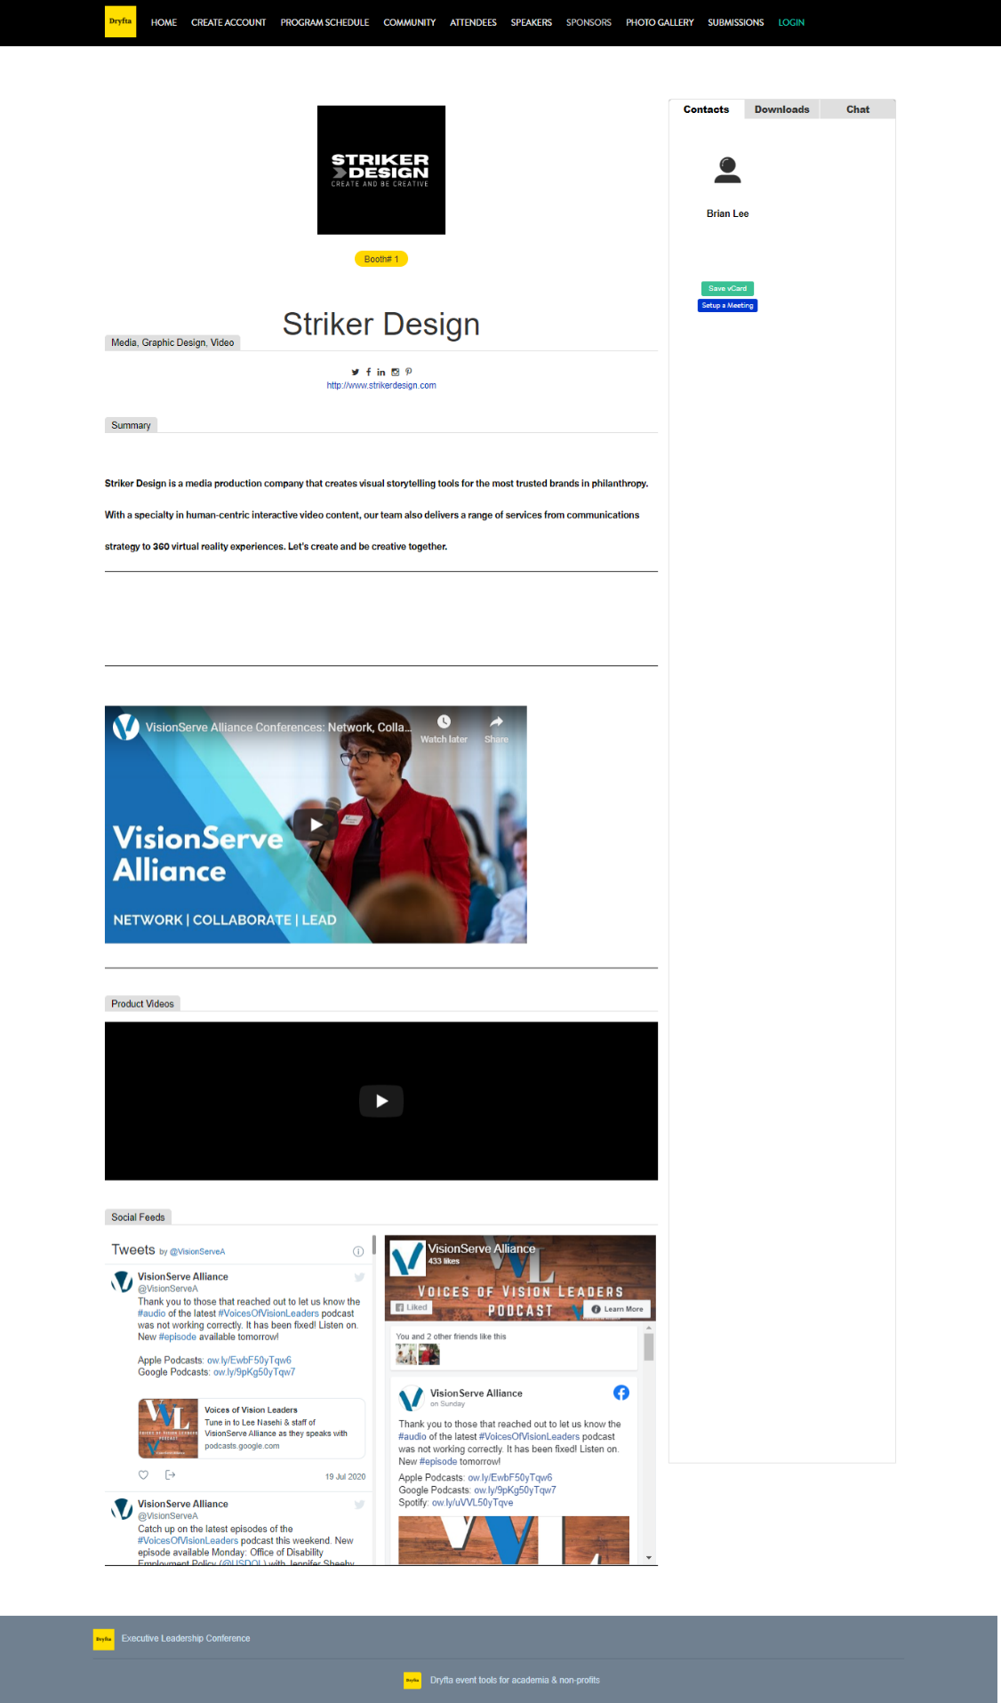
SAMPLE OF VIRTUAL EXHIBIT SPACE:
Virtual Exhibit booth
- Company Summary
- Social media buttons
- File downloader
- Set up 1-to-1 meetings
- Chat with attendees
- Videos
- Social Media Feeds
- Customer rep profiles and links to their attendee page
- Rich text editor for custom design of booth
Sponsor page
- Bio/summary
- Links
- Logo
- Linked on homepage

Here's an example sponsor page: https://symposium.dryfta.com/sponsors-ias/sponsor/detail/6/spacex

Available Benefits by Level: | $10,000  Title Sponsor | $5,000  Platinum  Level | $2,500  Gold  Level | $1,000 Silver Level | $500  Bronze  Level
Title Sponsor (logo on conference logo, co-branded conference, etc.) | √
Branded Events ($5,000 Exclusive; $2,500 joint) | √ | √ | √
Deliver pre-recorded session – 1 hour | √ | √
Live Commercial | 2 - (5 min) | 1 - (5 min) | 1 – (3 min)
Host branded networking lounge | √ | √ | √ | √
Virtual Exhibit Booth (Sponsor page PLUS 1-1 meetings, chat, documents, & video) | √ | √ | √ | √
Banner ad (sessions, calendar, homepage) | (2) | (2) | (2) | (1)
Provided attendees list post conference | √ | √ | √ | √
# of Free Registrations | Up to 8 | 4 | 2 | 1
Twitter & Facebook post announcing sponsorship | √ | √ | √ | √ | √
Sponsor page on event website (company summary, website & logo) | √ | √ | √ | √ | √
Company name/logo and on VSA website & registration page | √ | √ | √ | √ | √
Dedicated page on VSA’s website with customizable company information and links | √ | √ | √ | √ | √
Company name/logo in post-conference wrap-up Eblast | √ | √ | √ | √ | √

Additional Options:
- Email Blast ($150): Send a personalized email inviting attendees to your virtual space or sponsored program and/or direct them to your website
- Conference Home page Ad ($100): Place your graphic on the meeting home page linking to your virtual space or your web site.
- Conference Home page Banner Ad ($75): Place your Banner Ad on the meeting home page linking to your virtual space or your web site.
- Virtual Session Advertising ($150): Provide an advertisement in between educational sessions directing attendees to visit your virtual space. Graphics, text and links can all be included.
- Virtual Session Commercial ($250): Share your video commercial (up to 3 minutes) advertising your product and services between virtual sessions.

Contact us to discuss your custom sponsorship:
Ben Leigh, Digital Operations and Communications Manager, bleigh@visionservealliance.org
Wendy Hymes, Director of Conferences and Communications, wendy@visionservealliance.org

Deadlines to Sign Up:
Exclusive and Non-Exclusive Sponsorship packages are available on a 1st-come 1st-served basis and cannot be guaranteed to be available. In order to receive maximum exposure, Sponsors and Exhibitors should select and pay for their sponsorship/exhibit package by September 1st. Attendee registration will open September 15th. Remaining Sponsorships and Exhibit Booths will be available depending on availability.

Payment of Charges:
Sponsors & Exhibitors must make required payments for their virtual engagements by October 16, 2020. Thereafter exhibitors are further responsible for ensuring that there are no outstanding amounts owed by them to VSA. Exhibitors may not appear virtually until payment in full is received. If payment is not received prior to the start of the virtual meeting VSA will not allow for the display of their Virtual Booth Package or access to their virtual registrations.

Cancelation Policy:
All requests for cancellation or reduction of virtual engagement must be made in writing to info@visionservealliance.org by October 16, 2020 and shall become effective upon receipt by VSA. If written notice of cancellation is received by VSA on or before October 16, 2020 VSA will retain or shall be owed a cancellation fee of $150; if written notice of cancellation is received by VSA after October 16, 2020, VSA will retain or shall be owed a cancellation fee equal to 100% of the total exhibit fee.

