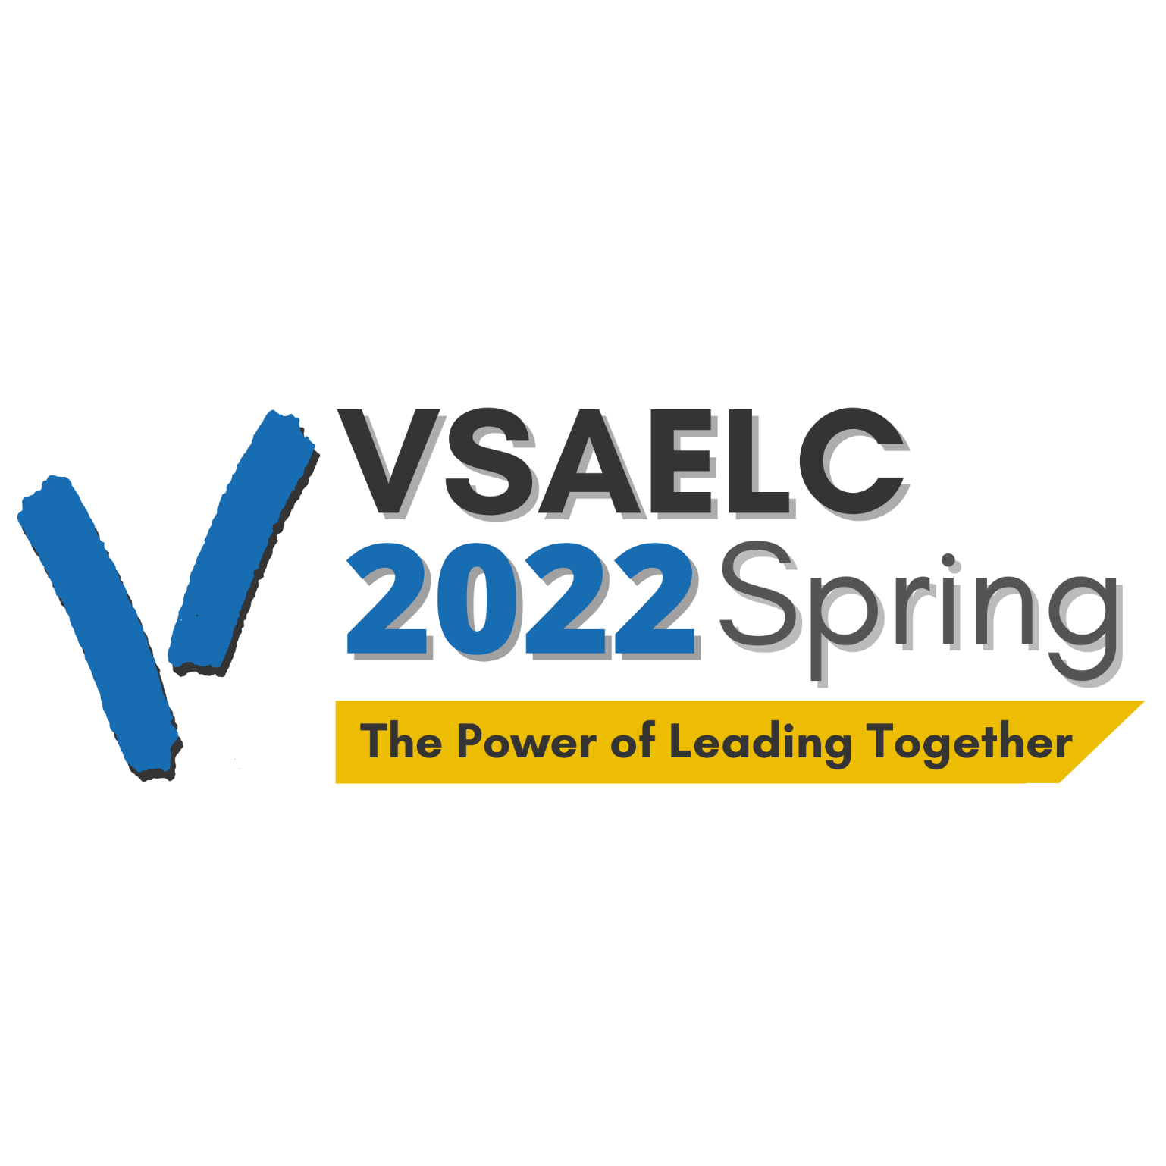

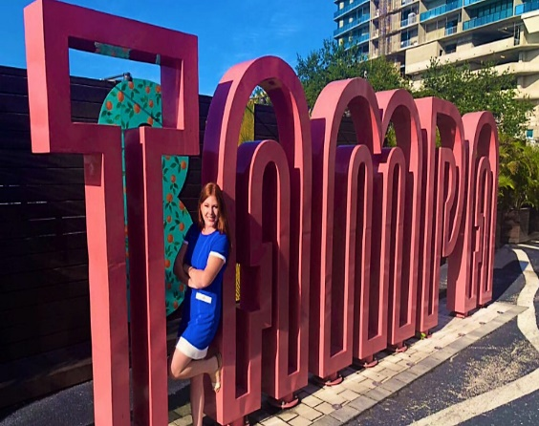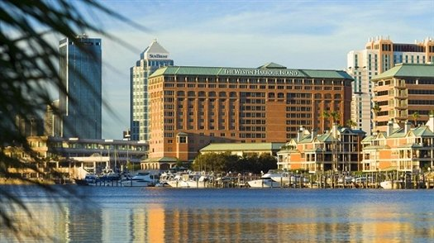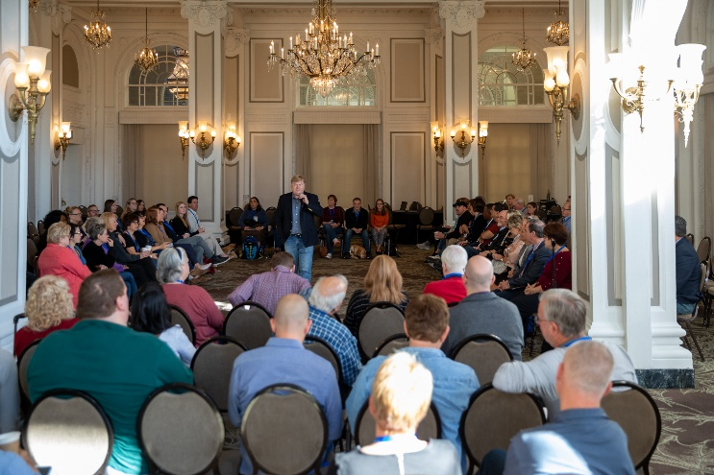

**VisionServe Alliance Sponsor and Exhibitor Prospectus**

**Executive Leadership Conference**

April 3 – 6, 2022

Tampa, Florida

Westin Waterside Hotel

**Dear Corporate Partners,**

We invite you to be part of the **2022 VisionServe Alliance Executive Leadership Conference** **April 3 – 6, 2022.** After nearly two years of meeting virtually, our members are looking forward to meeting in person in beautiful Tampa, Florida next spring! The VSA ELC will offer professional development, networking opportunities and fun and is expected to draw hundreds of our member leaders and their staff.

**Here are some reasons why you should be a Sponsor:**

* **VALUABLE YEAR-ROUND ACCESS TO THE DECISION MAKERS** - Your sponsorship packages include year-round advertising options to keep your company in front of your target audience especially the decision makers – the executive staff - giving you additional engagement opportunities throughout 2022 to interact and connect with potential customers.
* **EFFECTIVE LEAD GENERATION** - The online platform and app will give you access to attendee profiles, for easy follow up with your company representatives. After the event you’ll get analytics to conduct more informed follow-up.
* **IN PERSON AND ONLINE ENGAGEMENT OPPORTUNITIES** – See the table of Sponsorship benefits on p. 3 to choose the right combination of in person and online benefits such as an exhibit hall table, dedicated sponsor page on the virtual conference platform, event app with instant messaging and meetings with attendees at the click of a button.
* **FIRST IN-PERSON MEETING IN 2 YEARS –** Our last in person conference attracted 175 attendees; our last virtual conference drew over 400 attendees! Because this is our first in-person meeting in 2 years, we anticipate a much larger audience than in the past. For those who are not able to travel, there will be an on-demand library of session videos available.

New this year - we are offering ***year-round engagement opportunities*** for even more return on your investment. See the table of sponsorship packages on p 3 and select the branded engagement experiences on p 4 tailor made to meet your company’s goals. Our in person and online engagement options will give you a lot of flexibility to suit your company’s needs.

As always, VSA’s staff members are here to ensure we provide you with the exposure you are looking for. There are many options listed here, but if you don’t see the kind of package you’re looking for, reach out to us and we’ll create a custom package just for you. Branded sponsorship opportunities are available ***while quantities last*,** so reach out to us at your earliest convenience once you’ve made your decision. ***Registration is set to open mid-January.***

**We thank you for your company’s support of VisionServe Alliance and our members. We look forward to seeing you in Tampa!**

**Lee Nasehi**

President & CEO

VisionServe Alliance

|  |  |  |  |  |  |
| --- | --- | --- | --- | --- | --- |
| Available Benefits & Year-Round Engagements | $15,000  Title Sponsor | $7,500  Platinum  Level | $5,000  Gold  Level | $2,500  Silver  Level | $1,000 Bronze Level |
| Title Sponsor - co-branded conference with your logo embedded in the conference logo | √ |  |  |  |  |
| Live demo of products/services | 20 min | 10 min | 5 min |  |  |
| 60-minute Sponsor presented session *pending VSA approval | √ | √ |  |  |  |
| Length of session intro | 5 min | 5 min | 3 min | 2 min | 1 min |
| Exhibit Table in break area | √ | √ | √ | √ | √ |
| Virtual Exhibit Booth | √ | √ | √ | √ | √ |
| Branded Sponsor Opportunities (See p. 4) | √ | √ | √ | √ |  |
| Banner ads on sessions, calendar, homepage | (2) | (2) | (1) | (1) | (1) |
| Provided attendees list pre-conference | √ | √ | √ | √ | √ |
| # of Free Registrations for your staff | 4 | 3 | 2 | 1 | 1 (Booth Staff) |
| Exhibitor Showcase Mon & Tues | √ | √ | √ | √ |  |
| # of customized email blasts before or after | 3 (before, during &after) | 2 (before & during) | 1 (before or during) |  |  |
| Company name/logo on VSA website, event registration page and in all event emails | √ | √ | √ | √ | √ |
| Year-Round Engagements: | | | | | |
| # of Social Media shares *Subject to VSA approval | 8 | 6 | 4 | 2 | 1 |
| Ad in the VSA Member Portal | √ | √ | √ | √ | √ |
| Education Program Sponsors acknowledgement | √ | √ | √ |  |  |
| Sponsorship acknowledged at CREPE (regional events) | √ | √ | √ | √ | √ |
| # of VSA eNewsletter ads and mentions throughout 2022 | 4 | 3 | 2 | 1 | 1 |
| VSA-hosted Focus Group of qualified members | √ | √ | √ |  |  |
| Complimentary 1-Yr Associate Organization membership for one company contact | √ | √ |  |  |  |
| VVL podcast interview for relevant programs *Subject to VSA approval | √ | √ | √ |  |  |
| Young Professionals Scholarship $1,000 | Available | Available | Available | Available | available |

**ELC Branded Sponsorship Opportunities**

Branded sponsorship opportunities are available while qualities last, so reach out to us at your earliest convenience once you’ve made your decision. Registration is set to open mid-January. Sponsors will also be acknowledged with a clickable logo/banner ad in the event app and on the virtual event website.

**Title Sponsor - $15,000 Level**

Make a big impression by becoming the title sponsor for the entire ELC - Presented in partnership with [Your company]. Your company’s logo incorporated in the event logo, all signage. Discuss with us how you would like to see the event co-branded with your company and we can make it happen.

**Welcome Reception ($5,000 Exclusive; $2,500 non-exclusive)**

Make a name for your company during the premier networking event of the conference. Each year industry leaders unite at this must-attend VSA event! During this 2-hour evening event, you have the opportunity to create a link between your brand and VSA member leaders and their executive staff as everyone comes together to network. This opportunity gives you an extra showcase for your company from the podium (5 minutes for $5,000, 3 minutes for $2,500) to address all attendees as they enjoy a wide variety of food and beverage stations.

**Monday and Tuesday Keynote Session - $5,000 Exclusive; $2,500 non-exclusive**

Get off to a quick start to the conference by sponsoring one of our keynote speaker presentations. This sponsorship includes 5 minutes at the podium to address all attendees, and includes your company’s logo on all signage, printed and online listings and additional branding opportunities in the event app.

**Exhibitor Showcase ($2,500; non-exclusive) 6 slots available Monday and 6 on Tuesday**

Attendees select which showcases they want to attend. Use your time to 1) Demo your latest products 2) Hold a focus group to give advice on solutions to common member issues 3) Company rep-hosted Tec Chats about common issues; answer questions and share best practices with a national audience of industry professionals. Presentations are held in the main meeting rooms and Exhibit area each afternoon. Showcase topics will be included on the main Agenda.

**Networking Reception and Lead Panel Presenter ($5,000 Exclusive; $2,500 non-exclusive)**

Take the spotlight at a sponsored networking reception for attendees on Tuesday afternoon. You choose the topic. Attendees grab a beverage and some snacks while mixing and mingling, culminating in a moderated panel discussion on your chosen topic. Extra catering costs to be covered by the sponsor.

**Breakfast or Lunch ($5,000 Exclusive; $2,500 non-exclusive)**

Showcase your company during breakfast or lunch on Monday or Tuesday. The meal will feature dedicated signage for your company during a catered breakfast or lunch curated by the Westin Waterside. Includes a spotlight for your company representative to say a few words of welcome.

**AM Coffee Break ($2,500 – Exclusive)**

Be the center of attention by sponsoring attendees’ morning coffee pick-me-up! Tag your company as an industry leader including your company’s logo on all signage, printed and online listings and additional branding opportunities in the event app.

**Networking Activities at the ELC for Sponsor Company Representatives**

Meet and get to know the ELC attendees at these fun networking activities throughout the event:

Sunday Welcome Reception Pirate Water Taxi Tour

**Ybor City Historic Walking Tour Tampa Riverwalk**

**Online Engagement**

**\*Note: Our Accessibility Committee is still completing its Accessibility Audit on the event platform, so some of these features may not be used if they are not accessible**

* Large logo on event landing page, during Opening Session, before a speaker, and on the app
* Virtual Exhibit Booth branded with your company’s logo and signage where you can upload materials like On-Demand video content to be viewed before, during, and after the conference to highlight your product or service offerings; refresh content anytime you want.
* Make appointments with attendees and your company representatives; set up one-on-one meetings with attendees or link to a virtual room anytime to talk directly with attendees.
* Gamification encourages attendees to visit your booth.
* Expanded access the event platform, event app, and On-Demand video library 30 days before the event and 60 days after the event
* Complimentary Preliminary and Post-Show Attendee List

**Year-Round Engagement Opportunities**

Be recognized for your support not just at the conference, but also throughout the year:

* Your dedicated sponsor page on the VSA website
* Ads within the VSA Member Portal
* On social media
* Video commercial intros at virtual events
* Ads to intro Voices of Vision Leaders podcast episodes
* Ads in e-newsletters throughout the year.

**Additional year-round advertising packages are available. Talk to us about your options.**

**Education Program Sponsors** ($5,000 non-exclusive)

Be recognized for your support of year-round professional development opportunities for the VSA Community. Education Program Sponsors also receive complimentary registration for two (2) of their personnel to participate in VSA Education programs throughout the year and share information with attendees. 3-minute live or provide a pre-recorded video commercial

**VVL Sponsor & Exclusive Content**

Exclusive recorded podcast on sponsor’s topic of choice (*subject to VSA approval) for broadcast on the Voices of Vision Leaders podcast.

**Young Professionals Scholarships (**$1,000 non-exclusive)

Enable one (1) early-career professional to attend the 2022 VSA ELC or the Leadership Academy (happening Q1). YP Scholarship supporters will be recognized throughout the year at educational events.

**Timeline and How to Sign Up**

***Branded sponsorship opportunities are available while qualities last, so reach out to us at your earliest convenience*** or for more information. ***For maximum exposure, select your sponsorship opportunity by January 10th*** before Attendee registration launches in mid-January.

***If you asked to transfer your sponsorship from the 2021 CEO Summit in Albuquerque, NM to the Tampa conference, please contact Wendy Hymes to select your preferred sponsorship branded opportunities.*** Email Wendy at [wendy@visionservealliance.org](mailto:wendy@visionservealliance.org) or call (314) 257-0530.

Click here [INSERT LINK] to view and purchase your ELC sponsorship packages.

Click here [INSERT LINK] to view the conference registration page and book your room in the hotel room block at the Westin Waterside Hotel at the rate of $220/night.