AVLNC Access to Quality Services Committee
Abstract
This toolkit identifies the multiple impacts of vision loss on every aspect of providing services to older adults
Aging and Vision Loss National Coalition (AVLNC) Service Provider Toolkit

Contents
Introduction 2
Working with Blind and Visually Impaired Individuals Understanding Vision Loss 3
Common Eye Conditions That Cause Low Vision 4
Common Eye Conditions 5
Identifying if Someone may have a Vision Problem 7
Blindness Etiquette 8
When Guiding an Individual Who Is Blind 9
Barrier Removal in Facilities and Providing Access to Programs 10
Adaptive Recreation, Leisure, Sports 13
Self-Advocacy 14
Sources for Additional Information Ways your organization can connect to information about Vision Loss 16
Prevalence 19

Introduction
Nearly half of all people in the United States over the age of 65 already have AT LEAST one of the following three eye diseases: glaucoma, diabetic retinopathy, and macular degeneration. (/www.ncbi.nlm.nih.gov/pubmed/12963614)
In the past 5 years, longitudinal studies have shown that 60% of older adults (age 65 and over) are living with severe vision loss.
The Aging and Vision Loss National Coalition is working to ensure that all older people receive high quality, comprehensive specialized vision rehabilitation, including low vision services.
Most older adults have some connection with the broad-ranging Aging Network and to a lesser degree with the smaller corps of Vision Rehabilitation providers but both of these direct service delivery systems have shared scopes of practice.
This toolkit identifies the multiple impacts of vision loss on every aspect of providing services to older adults. Every plan for every older person will see improved outcomes when vision loss is identified and accommodations are included in treatment, whether it be in home health, residential services, hospital and hospital discharge planning, occupational or physical therapy, recreation, mental health services, retirement planning, insurance, legal/guardianship, and all manner of multi-faceted services.
Use this toolkit to facilitate best practices among all who work with older adults: a functional assessment leading to individual service/treatment plans leading to maximum quality of life.

Working with Blind and Visually Impaired Individuals Understanding Vision Loss

Vision loss varies by eye condition and by individual. The most common causes of low or no vision among older people are age-related macular degeneration, glaucoma, diabetic retinopathy, and cataracts.
Legal Blindness vs Low Vision
The term “legal blindness” refers to a definition the government uses to determine eligibility for many different services. It means a visual acuity of 20/200 or worse in the better-seeing eye with best correction (regular glasses or contact lenses) or a visual field (the total area an individual can see without moving their eyes from side to side) of 20 degrees or less (also called tunnel vision) in the better-seeing eye.
Implications of Vision Loss
Most individuals with vision loss living in our community will have low vision, which means that even with regular glasses, contact lenses, medication, or surgery, it is difficult for them to perform everyday tasks, including walking, driving, reading, and recognizing people. The most important information you need to know when working with older people with vision loss is:
1. How vision loss affects the ability of each older person to function, and
2. Different eye conditions cause different types of vision loss, as depicted below.

Common Eye Conditions That Cause Low Vision

 | 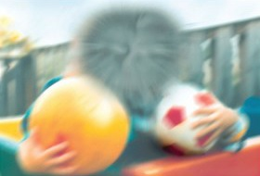
Scattered Scotomas | Central Blind Spot (Scotoma) | Peripheral Field Loss
 |  | 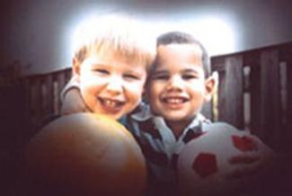
National Eye Institute, National Institutes of Health

Blind spots and blurriness can interfere with reading or recognizing someone’s face, which require good central vision. People with age-related macular degeneration or diabetic retinopathy often experience these changes in their functional vision. And, before you ask, glasses cannot help them see better.
Older people with peripheral field loss most often experience tunnel vision which affects their ability to see objects to the right, left, above, and below where they are looking. This can result in not seeing someone approach from the side or tripping and falling. People in the early stages of dementia also experience tunnel vision, which, along with cognitive decline, will impact their ability to navigate the community.
Imagine if you had to wear a SCUBA mask all the time. What if someone smeared Vaseline on the inside of the mask? Not all people with tunnel vision have 20/20 acuity. What if the tunnel of vision you have is the size of a paper towel tube or a soda straw? Now, you have a clearer picture of tunnel vision.
Normal age-related vision changes can make it hard to navigate the world safely. Older people may experience blurry vision, poor night vision, sensitivity to glare, increased time needed to adjust to bright or low light settings, reduced contrast sensitivity, and reduced ability to focus on fine detail. Light levels play a critical role in the ability to see and get around in both familiar and unfamiliar areas. If there is too much glare, light can effectively “blind” someone as well as create shadows that look like obstacles. Depth perception may also be poor. When one eye has better vision than the other, it is difficult for older people with vision loss to judge the height of steps or curbs, so their risk of tripping or falling is increased.

Common Eye Conditions
National Eye Institute, National Institutes of Health

The following list gives a brief description of common eye disorders that may lead to severe vision loss.
Cataract. Blurry, hazy, multiple images, glare sensitivity, diminished color perception, decreased night or low light vision. Most common in individuals over the age of 55.
Macular degeneration. Central vision and color perception distorted or fuzzy, vision difficulty with reading and facial recognition most common cause of vision loss. Treatments can slow the progression of the wet type of macular degeneration, but for dry macular degeneration, there currently is no treatment. The changes are permanent and slowly get progressively worse over time.
Glaucoma. Results in side vision loss, tunnel vision, blurred central vision, seeing colored rings on lights. More common after the age of 40.
Diabetic retinopathy. Patches of vision loss (blind spots), cloudy vision, glare sensitivity, decrease night or low light vision.
Retina detachment. Separation of the retina from the back of the eye.
Retinitis pigmentosa. Progressive loss of side vision creating a tunnel in which a small portion of the central vision is usable.
For additional information on common eye conditions visit:
National Eye Institute – Eye Conditions and Diseases
https://www.nei.nih.gov/learn-about-eye-health/eye-conditions-and-diseases
Iris vision Most Common Eye Problems – Signs, Symptoms and Treatment Options https://irisvision.com/most-common-eye-problems-signs-symptoms-and-treatment/

Vision Loss Simulators and Videos
Eyesight on Wellness - Look through the lens of common eye conditions
https://www.eyesiteonwellness.com/eye-diseases/

Vision Aware -Vision Simulation Video
https://visionaware.org/your-eye-condition/eye-health/vision-simulation-video/

Identifying if Someone may have a Vision Problem

Observations that may suggest poor or diminishing vision:
- Person defers any writing task to partner, friend or staff.
- Person asks another to read any printed text, such as menu selections or activity directions.
- Person may bump into or step too close to furniture or another person or move less confidently through the environment.
- Person may not recognize common items that are to be picked up, such as food in a cafeteria line or items in a craft project.
- Person may not seem to recognize another person who they know or may seem to ignore a familiar person who is physically near.
- Change in person’s level of involvement in formerly enjoyed activities.

Blindness Etiquette

- Always treat people who are blind or have low vision as individuals. People with visual disabilities come in all shapes, sizes, and colors. They each have their own strengths and weaknesses, just like everyone else.
- When interacting with someone who is blind:
- Identify yourself, especially when entering a room.
- Speak directly to the individual.
- Give specific directions like, "The chair is two feet to your right," as opposed to saying, "The chair is over there."
- Give an accurate picture when describing things to an individual with vision loss. Include details such as color, texture, shape, and landmarks.
- Get the individuals attention by touching them on the arm or use their name when addressing them. This lets them know you are speaking to them, and not someone else in the room.
- If you see the individual is struggling introduce yourself and ask the person how you can assist them.
- Provide assistance if it is requested.
- Respect the individual’s wishes if they decline assistance.

Printable Handout
Basic Etiquette: People with Visual Impairments - National Center on Workforce and Disability
https://frdat.niagara.edu/assets/Etiquette-Handouts/NCWD-Basic-Etiquette-Visual-Impairments.pdf

When Guiding an Individual Who Is Blind

Allow the person you are guiding to hold your elbow and follow as you walk.
- In tight spots such as narrow aisles or through doorways, move your guiding arm behind your back when approaching the narrow space so the person you are guiding can step behind you and follow single file.
- Pause briefly at a curb or at the beginning of a flight of stairs and inform the individual of the curb or stairs.
- Always inform the individual if the approaching steps go up or down.
- Allow the individual to locate the handrail and the edge of the first step before proceeding.
- Use words such as "straight ahead," "turn left," "on your right." when describing information about the environment.
Resources
Video by Signal Centers Inc
https://www.youtube.com/watch?v=AuGb4yge-ys
7 1/2-minute video on Sighted Guide Technique. In this video a Certified Orientation & Mobility Specialist (COMS) teaches you how to walk comfortably with a companion who is blind or visually impaired.
Sighted Guide Hand out by the Braille Institute
https://www.brailleinstitute.org/wp-content/uploads/2018/05/Braille-Institute-Sighted-Guide-Techniques-to-Help-You-Help-Others.pdf

Barrier Removal in Facilities and Providing
Access to Programs

“If people can’t do what they want to do, they won’t do what they need to do.” Linda Fugate, Certified Vocational Rehabilitation Therapist
Barriers typically fall into one of three categories:
- Facilities access
- Policies and practices
- Communication
Light is an aspect of the physical environment that can create a barrier to participation for persons with vision impairment. Light sensitivity and glare can make it impossible to use residual vision. Controlling light is an important need.
For some, too much light from windows or overhead lights can reduce vision. An individual may wear filter glasses (sunglasses) to increase comfort in an area where there is too much bright light, both inside and outside. Some may choose to sit with their back to a light source. Others may wear a hat with a visor to reduce the effect of too much light.
On the other hand, most people with vision impairment need good task lighting. That means, a light that is about 10-inches off a work surface and positioned so it’s not shining in the eyes. A task light enhances whatever is being done on the work surface, which could be a craft project, a large print flyer, a card game, or a dinner plate. The color of the bulb in the task light is important, but it has to be determined on an individual basis. Some with vision impairment prefer a soft, yellow bulb; others prefer a bright, white bulb.
It is important to remember that many older adults with vision loss may also have a hearing loss. A large space may create an echo-like environment, making it hard for people to hear others. Some with vision and hearing loss depend on sitting in front of another so they can see lips and changes in facial affect. Try and match the space to an activity that keeps all comfortable.
Policies and practices can create barriers for those with vision impairments. A practice of not making all activities accessible for those with a disability reduces their participation and increases their isolation. Almost all activities can be made safe and accessible. A policy of not allowing a family member or friend to freely accompany a person with vision impairment on outings can reduce a person’s comfort level in choosing to go on outings. A practice of having committee or board meetings in the evening and not on a public transportation route might eliminate a person from signing up to serve. Not offering print materials in alternate forms significantly reduces participation by persons with vision loss.
General accessibility statements on event or in web-based materials which state or ask if a participant needs reasonable accommodation or assistance to better access your programs is always recommended.
Communication should be accessible regardless of disability. The weekly menu or monthly activity sheet presented in a 14-point font is not going to be accessible to most people with vision loss. A website used to register for activities needs to be screen reader friendly as well as stable when magnified or when a high contrast black background/white text is used.
Make sure your programs are accessible to a wide range of people with disabilities. Sometimes it can be as simple as providing large print calendars of events and flyers, other times it is making sure your web site is accessible to those who use screen reading or screen enlargement software.
Always remember that regardless of vision loss all your participants are different, and many participants can have a variety of secondary disabilities that may factor into how they access and participate in your programs.
An example in which you might have to think outside the box might be in a recreation and leisure program. Some ideas to consider adding to your program:
Game Nights: If Bingo is an activity that you do in your senior program you can make or purchase large print or Braille bingo playing cards.
Many other popular games are also available in other formats from UNO to Cards Against Humanity for minimalcost.
Movie Nights: If you hold movie nights for participants consider choosing movies that have audio description. These can be purchased or streamed through subscription services such as Netflix. This allows individuals who have difficulty seeing the screen full access to the action and to be an equal participant in the movie night. It also fosters community education that your organization is sensitive to community needs.
A list of audio-described media can be found at the Audio Description Project. https://adp.acb.org/masterad.html
Recreation and Leisure: Physical activities such as tours, crafts, or sports can be made accessible through staff and volunteers who have been trained in blindness etiquette and human guide onsite to assist participants in the activity. Examples are a participant who may need hand under hand assistance in completing an art task, or a participant who may need a sighted guide to assist in navigating the local venue being toured.
Remote Social Engagement Opportunities: Accessible platforms for virtual events need to be considered when developing remote and hybrid options. To obtain more information on options reach out to a local blindness organization or contact the regional ADA Disability and Technical Assistance Center. Both will be able to provide you with tips and information on which platforms work better than others, as well as accessibility information to assist your participants.

Resources
Virtual Senior Center
www.vscm.selfhelp.net
Institute on Aging Friendship Line
https://www.ioaging.org/services/friendship-line
415-750-4111 or toll free at 800-971-0016
Lighthouse Guild Tele-Support for Adults
https://lighthouseguild.org/support-services/telesupport-groups/tele-support-for-adults/

Adaptive Recreation, Leisure, Sports
One path to happiness and good health is by “imperative movement.” Just like we need water, oxygen, and food, we also need to move our bodies on our own power, EVERY DAY!
Sports, recreation and physical activity for people who are blind and have low vision of all ages and abilities can increase quality of life and life satisfaction as it allows for social interaction and provides health benefits that help buffer the adverse effects of stressful, busy lives. From blind babies, to children, adults, and seniors, some of the many benefits include improved cardiovascular function, gross and fine motor skills development, better ability to sleep, improved self-esteem, increased stamina, and decreased stress levels. Each of these benefits may not only improve quality of life but can also have a positive effect on the individual’s other daily activities ( https://bctra.org/wp-content/uploads/tr_journals/971-3804-2-PB.pdf).

Resources
Vision Loss and Sport
https://www.betterhealth.vic.gov.au/health/conditionsandtreatments/vision-loss-and-sport
Sports and Exercise Tips
http://www.westsidespirit.com/news/sports-and-exercise-tips-for-people-who-are-blind-or-visually-impaired-DY1625317
Blind Sports and Recreation Resources
https://www.ntac.blind.msstate.edu/resources/blind-sports-and-recreation-resources

Self-Advocacy

When working with older adults you may have to help them understand how they can become a better self-advocate. Many may have a basic understanding of what “self-advocacy” is but may need your guidance to better define it. At the heart, self-advocacy is the ability to communicate individual needs and wants. Self-advocacy fosters independence and empowers individuals to find solutions to problems that others might not be aware of.
Individuals with vision loss may often learn self-advocacy skills in incremental steps. They may start with just understanding one of their challenges. Or they may be able to say that something is wrong, but not know what would help. This is self-advocacy, too.
The following questions can help guide the discussion to help identify where advocacy may be needed in the individual’s life:
- What is the decision you need to make?
- What decisions could you make?
- Evaluate each choice. What are the pluses and minuses of each choice?
- Describe which choice is best for you?
- Did you make the best choice for you?

Characteristics include:
- Awareness of personal preferences, interests, strengths, and limitations.
- Self-confidence.
- Creativity (such as creating other accommodations that help support the need of the individual)
- Problem-solving skills.
- Ability to differentiate between wants and needs.
- Ability to make choices based on preferences, interests, wants, and needs.
- Ability to consider multiple options and to anticipate consequences for decisions.
- Ability to initiate and act when needed.
- Ability to evaluate decisions based on the outcomes of previous decisions and to revise future decisions accordingly.
- Ability to set and work toward goals.
- Finding a balance and striving for independence while recognizing interdependence with others.
- Ability to self-regulate behavior.
- Self-evaluation skills.
- Independent performance and adjustment skills.
- Ability to use communication skills such as negotiation, compromise, and persuasion to reach goals.
- Polite persistence.
- Ability to assume responsibility for actions and decisions.

Sources for Additional Information
Ways your organization can connect to information
about Vision Loss

Hadley
https://hadley.edu/
800-323-4238
Three ways to learn: workshops (quick, practical advice from experts), audio podcasts (recorded audio talk shows), and discussion groups (listen live and chat with others who share your interests).
VisionAware
https://visionaware.org/
Free, easy-to-use information source for adults with vision loss, their families, caregivers, healthcare providers, and social service professionals.
Living Well with Low Vision
https://lowvision.preventblindness.org/
Includes “A Self-Help Guide to Non-visual Skills”, 21 categories of daily activities, along with the alternative nonvisual senses that can be enlisted to accomplish each activity.
Older Individuals Who Are Blind Technical Assistance Center
https://www.oib-tac.org/direct-service/curriculum/
OIB-TAC and National Research and Training Center on Blindness and Low Vision (NRTC)
Lessons that share tips for how to safely and efficiently complete daily life activities. Tips can be downloaded in print or audio and in English or Spanish.
https://nrtc.catalog.instructure.com/
Courses that will benefit you and your staff, and provide continuing education credits, are available here from the National Research and training Center on Blindness and Low Vision. All types of free courses from Anatomy and Physiology of the Eye to Teaching Art.
Prevent Blindness Adult Vision Screening Certification Course
https://preventblindness.org/adult-vision-screening-certification/
This course provides participants with a three-year, nationally recognized certificate based on current national guidelines and best practices for evidence-based vision screening tools and procedures. Currently offered only in Ohio and Wisconsin.
Lighthouse Guild
https://lighthouseguild.org/training/elearning-for-professionals/
eLearning educational programs for professionals and others to provide the very best care and services for people with vision loss.
Association for Education and Rehabilitation of the Blind and Visually Impaired (AER)
https://aerbvi.org/the-national-accreditation-council/higher-education/
The AER Accreditation Program for institutions of higher education is designed to ensure that colleges and universities across the United States and abroad are offering vision services personnel preparation programs in orientation and mobility, low vision, vision rehabilitation and assistive technology that meet high-quality standards.
ElderCare Locater
https://eldercare.acl.gov
The ElderCare Locator is a national resource program that can be the first step in locating state or local services that are available to a consumer in their community.
Regional 211 Programs Information Lines - Connecting You to Your Community
211 is an easy to remember telephone number assigned by the Federal Communications Commission to streamline access to health and human services. These services are available on a 24-hour basis to connect residents to a wide variety of human services or social services in their area.
American Printing House for the Blind (APH) Connect Center
https://aphconnectcenter.org/#content
800-232-5463
Looking for resources and services related to vision loss? The trained staff of the APH Connect Center Information and Referral Line are here to help.
American Council of the Blind (ACB)
https://acb.org/
800-424-8666
A consumer group for persons with vision loss. You’re not alone in your journey through vision loss and blindness. ACB welcomes and accepts you. Guided by its members, ACB advocates for equality of people who are blind and visually impaired, inspires community, and connects you with education, resources, and each other to support your independence.
ACB Radio - events are available by phone.
https://acb.org/acb-radio
Are you looking for late-breaking information from a blindness perspective? Are you wanting to hear creative blind broadcasters present music from dozens of music genres? Do you love old-time radio shows? If so, tune in to ACB Radio.
National Federation of the Blind (NFB)
https://nfb.org/
A consumer group for persons with vision loss. The National Federation of the Blind knows that blindness is not the characteristic that defines you or your future. Every day we raise the expectations of blind people, because low expectations create obstacles between blind people and our dreams. You can live the life you want; blindness is not what holds you back. NFB had a free white cane program.
NFB Newsline
https://nfb.org/programs-services/nfb-newsline
NFB-NEWSLINE is a free audio news service for anyone who is blind, low-vision, deafblind, or otherwise print-disabled that offers access to more than 500 publications, emergency weather alerts, job listings, and more.

Prevalence

“Vision problems are almost universal among nursing home residents.” John Crews, Health Scientist, retired, US Centers for Disease Control and Prevention. (Monaco et al., Journal of the American Medical Directors Association. https://www.sciencedirect.com/science/article/abs/pii/S1525861020307428)

Estimated Growth in the Number of Persons with Vision Impairment
During the next three decades, the population of adults with vision impairment and age-related eye diseases is estimated to rapidly increase due to the aging U.S. population. In addition, diabetes as well as other chronic diseases will contribute to an increasing population of people who experience vision loss.
Estimated Numbers of Persons with Visual Impairment in the United States by Race/Ethnicity (All Persons) and Year
https://www.cdc.gov/visionhealth/risk/burden.htm

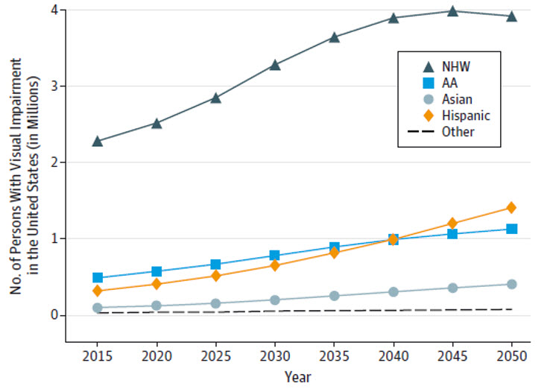
AA indicates African American; NHW, non-Hispanic white.
Varma et al., JAMA Ophthalmology, 2016. https://www.ncbi.nlm.nih.gov/pmc/articles/PMC5116104/

Prevalence of Visual Acuity Loss and Blindness in the U.S.
https://preventblindness.org/prevalence-visual-acuity-loss-blindness-us
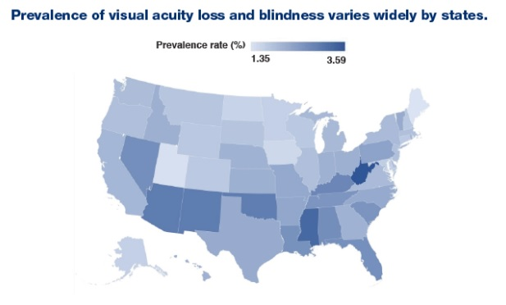
Flaxman et al., JAMA Ophthalmology, 2021.
https://jamanetwork.com/journals/jamaophthalmology/fullarticle/2779910

State Profiles on Vision and Eye Health
https://www.cdc.gov/visionhealth/data/state-profiles/index.htm
These state profiles present an overview of the impact of vision impairment and comorbid conditions in the United States in all 50 states. The profiles present nationally representative data from The American Community Survey (ACS) and The Behavioral Risk Factor Surveillance System (BRFSS). Below is an example.

Example Wisconsin: The Impact of Vision Impairment
