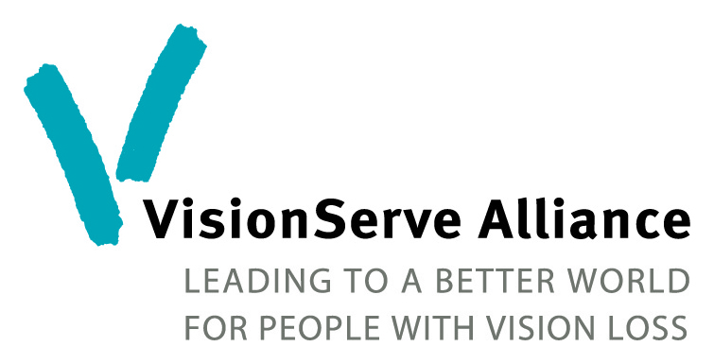


Assistive Technology Funding 2023
The Inspiration Foundation in partnership with VisionServe Alliance has created a fund to assist VSA member organizations to purchase assistive technology equipment for classrooms. The Inspiration Foundation’s Board believes strongly that successful job placement and retention depends on strong technology skills, and that independent living skills are augmented by technology. They also recognize how difficult it is for nonprofit organizations to keep their technology class rooms up to date. Send applications to info@visionservealliance.org Deadline for application submissions UPDATED: Wednesday, March 1, 2023. Awards will be announced at the CEO Summit March 28th.
Criteria:
- Current VisionServe Alliance Nonprofit Member
- UPDATED: Now open to organizations of any size
- Maximum grant request of $2,000
- If awarded a grant, you must submit an impact report detailing how this award has helped your agency, proof of publicity of your award on your agency’s website, social media and newsletter. Further details will be provided to awardees.
Application Information:
Fresno, CA 93711-3204

Date:
Organization Name & Mailing address:
ED/CEO Name & email:
EIN:
# Tech students in most recent fiscal year:
Amount Requested: $
Check AT equipment you are requesting to purchase:
Desktop Tablet
Laptop Software: JAWS, Zoom text, etc
Printer Other (Describe):
Braille

Please describe how being able to purchase this equipment will help your assistive technology program/services:
For VisionServe Alliance Use Only:
Date Received:
Amount Awarded:

