Kentucky’s Older Population
and Vision Loss:
A Briefing

8760 Manchester Road
St. Louis, MO 63144
VisionServeAlliance.org
(314) 961-8235

November 28, 2022

Prepared by:

Suggested Citation: VisionServe Alliance (2022). Kentucky’s Older Population and Vision Loss: A Briefing, St. Louis.

Contents

Executive Summary 4
Kentucky’s Older Population and Vision Loss: A Briefing 5
Purpose 5
Introduction 5
Vision Impairment in Kentucky 7
Demographic Characteristics 7
Geographic Distribution 8
Figure 1. County Level Estimated Prevalence of Vision Impairment and Blindness by County, Kentucky, American Community Survey, 2019. 9
Chronic Conditions 9
Figure 2. Chronic Conditions among People with and without Vision Impairment, Kentucky, 2019, BRFSS 10
Health-Related Quality of Life 11
Figure 3. Health-Related Quality of Life among People Aged ≥65 Years, with and without Vision Impairment, Kentucky, 2019, BRFSS 11
Disability Status 12
Figure 4. Disability Status among People Age ≥65 Years with and without Vision Impairment, Kentucky, 2019, BRFSS 13
Social Determinants of Health and Health Equity 13
Discussion 14
Conclusion 14
References 15
Acknowledgements 16
Appendix A: Methods 17
Appendix B: BRFSS and ACS Tables 19
Appendix B, Table 1. Prevalence of Visual Impairment by Age and Race/Ethnicity in People Aged 65 and Older, BRFSS, United States and Kentucky, 2019 19
Appendix B, Table 2. Prevalence of Vision Impairment among People Age ≥65 Years by County, Kentucky, American Community Survey, 2019 20
Figure 1. Estimated Prevalence of Vision Impairment among People Aged ≥65 Years by County, Kentucky, American Community Survey, 2019 29
Figure 2. Chronic Conditions among People Aged ≥65 Years with and without Vision Impairment, Kentucky, 2019, BRFSS 30
Figure 3. Health-Related Qualify of Life among People Aged ≥65 Years with and without Vision Impairment, Kentucky, 2019, BRFSS 30
Figure 4. Disability Status among People Aged ≥65 Years, with and without Vision Impairment, Kentucky, 2019, BRFSS 30
Appendix D: Vision Rehabilitation Resources 31

Executive Summary

This briefing is designed to assist policy makers and service providers better understand the characteristics and circumstances of older people with vision impairment in Kentucky. Data from the Behavioral Risk Factor Surveillance System and the Census provide considerable insight into the population of people experiencing vision loss. Almost 10% of older Kentuckians report severe vision impairment, with men (9.5%) and women (9.8%) reporting about the same prevalence of vision impairment, but women with vision impairment comprise 56% of the older population. African Americans report a higher prevalence of vision impairment than whites. Vision impairment is not evenly distributed across the state. The prevalence of vision impairment among people aged 65 years and older by county ranges from about 3.3% to 23.5%.

Older people with vision impairment have lower levels of education and are poorer than older people without vision loss. Thirty-one percent of older people with vision impairment have not graduated from high school, and 32% have annual incomes below $20,000. In addition, older people with vision impairment report higher prevalence of chronic conditions, particularly stroke, arthritis, diabetes, kidney disease, and depression. Not surprisingly, then, 48% of older people with vision impairment in Kentucky compared to 27% among older people without vision impairment report fair or poor health. Moreover, 41% of older people with vision impairment report 14 or more days of poor physical health in the past 30 days compared to 17% of those without vision impairment. Similarly, 14% of people with vision impairment report 14 or more days of poor mental health compared to 7% of those without vision loss. This disparity in quality of life is repeated in activity limitation days, where 30% of people with vision impairment report 14 or more days of activity limitation compared to 20% among those without vision impairment.

Upstream factors including poverty and lower education have the potential to contribute to higher prevalence of chronic conditions and poorer health-related quality of life. These factors may lead to increased disability, including increased difficulty walking, dressing/bathing, and doing errands.

Data from state and national surveys provide quantitative information regarding health, chronic conditions, and quality of life factors associated with vision impairment in Kentucky. These data, when informed by the personal experiences of people who have lost vision, serve to define policy decisions and interventions to preserve the independence, dignity, and autonomy of older people with vision impairment. By aligning aging services, public health initiatives, transportation resources, and vision rehabilitation programs to meet the needs of older people with vision impairment, there is potential to improve health, quality of life, and function.

Kentucky’s Older Population and Vision Loss: A Briefing

Purpose

This briefing provides estimates of the prevalence of vision impairment among older people in the state of Kentucky at the state and county level. Using state and national data systems, this report describes self-reported health, prevalence of chronic conditions, and quality of life among older people with and without vision impairment. The findings show that an estimated 9.7% of older people in the state report vision impairment, and they report substantial health and social disparities compared to older people without vision impairment, differences that potentially compromise function and quality of life. By better understanding the circumstances of older people with vision impairment in Kentucky, policy makers and providers can tailor services in aging, public health, transportation, and vision rehabilitation to preserve the dignity, independence, and quality of life of older people.

Introduction

Vision impairment and blindness often have profound effects upon older people and those who care for and about them. Vision impairment can make common activities difficult or impossible; for example, climbing stairs, crossing a street, driving, using public transportation, preparing meals, and performing household activities may be compromised. Older people experiencing vision impairment may have difficulty managing accounts, paying bills, and identifying prescribed medications. Falls or fear of falling may further compromise their independence. Vision impairment is often isolating, keeping people at home when they prefer to be with family and friends. Many older people with vision loss do not interact with others who are going through the same experience, creating further isolation and depression.
An estimated 9.7% of older Kentuckians report vision impairment or blindness. Those most at risk for vision impairment are African Americans and older age groups. Older people with vision impairment are more likely to report less education and to experience poverty. They are also more likely to have age-related chronic conditions compared to older people without vision impairment. As Kentucky’s population continues to age, the number of people experiencing vision impairment will likely increase.
While the circumstances and risk factors associated with aging and vision loss are serious, much can be done to ameliorate the effects of vision impairment. For example, improved access and utilization of vision and eye health, as well as the availability of comprehensive vision rehabilitation service providers, promoting independence and autonomy, are effective strategies often enabling older people in Kentucky to live independently and remain in their community.

National Perspective
A recent study estimated that 12.5 million people over the age of 40 years in the United States experienced vision impairment. Of those, 1.02 million were blind (visual acuity 20/200 or worse, 3.22 million had vision impairment (visual acuity of 20/40 to less than 20/200), and 8.2 million had uncorrected refractive error. By 2050, the population of people with vision impairment is expected to increase by 118%. The greatest increases will be among women, older people, African Americans, and Hispanics.¹
In addition to representing a large and growing population, older people with vision impairment generally have a greater likelihood of reporting other medical conditions, such as, diabetes, stroke, hypertension, heart disease, and hearing impairment than people without vision impairment.² They are twice as likely to fall as people without vision impairment.³ Moreover, people with vision impairment are more likely to report oral health problems.⁴ Perhaps because of these circumstances, older people with vision impairment are more likely to report higher levels of depression,⁵ poor quality of life (QOL),⁶ and overall poorer health than people without vision impairment.²
Vision impairment is not evenly distributed across the United States.¹ States with higher proportions of older people and racial/ethnic minorities tend to have higher prevalence of vision problems.¹
Additional research shows that people with vision impairment are less likely to access routine medical care, and they are less likely to have access to and utilize eye care.⁷
Responding to this complex set of circumstances requires thoughtful, innovative, well-integrated strategies by multiple entities to address the varied health and rehabilitation needs of older people with vision impairment. Among those entities are eye care providers, the aging network, public health, transportation, and housing, as well as comprehensive vision rehabilitation services.
Vision Rehabilitation Programs
A central component of supports for older people with vision impairment is a network of public and private agencies providing vision rehabilitation services addressing communication, activities of daily living, personal care, self-advocacy, travel and mobility skills, diabetes, and medication management, as well as access to assistive technology (e.g., smart phones, tablets, and computers). Services often include counseling, information, and referrals to community resources and supports. Vision rehabilitation services generally include low vision evaluations and the provision of adapted vision devices. Moreover, older people with vision impairment benefit from peer support groups where older people share common experiences and exchange information about successful management strategies. These services are often provided in the client’s home or in an agency setting. The sum of vision rehabilitation services improves independence, self-esteem, health, and quality of life.
Despite the best effort of these agencies, only about 3% of older people with vision impairment nationally receive vision rehabilitation services (see healthypeople.gov here). This gap between need and response represents a major public health and public policy concern recently addressed by a National Academies of Science, Engineering, and Medicine (NASEM, formerly the Institute of Medicine) seminal report Making Eye Health A Population Health Imperative: Vision for Tomorrow.⁸ The NASEM report asserted, “Vision rehabilitation is essential to maximizing the independence, function, participation, safety, and overall QOL of people with chronic vision impairment. Yet there are numerous barriers to high quality and universally accessible vision rehabilitation services” (p. 414).⁸ A goal of Healthy People 2030 is to increase access to vision rehabilitation services by only 10%, to 3.3% over a ten year period (see Healthy People 2030 here).
This report examines data from the 2019 Behavioral Risk Factor Surveillance System (BRFSS) and the 2019 American Community Survey to characterize older people with vision impairment at the population level in Kentucky. See Appendix A for methods.

Vision Impairment in Kentucky

Demographic Characteristics

An analysis of 2019 Behavioral Risk Factor Surveillance System data reveals that 9.7% of people 65 years of age and older report vision impairment in response to the question, “Are you blind or do you have serious difficulty seeing, even when wearing glasses?” (See Appendix A.)
While 9.8% of older women over age 65 years report vision impairment, 9.5% of men do so. Women, however, comprise 56% of the older population of people with vision impairment. In Kentucky, vision impairment varies by race: 9.3% of whites report vision impairment compared to 12.1% among African Americans. (See Table 1.)
Table 1. Prevalence of Vision Impairment by Age, Sex, and Race/Ethnicity among People Aged 65 Years and Older, Kentucky, BRFSS

Characteristic | Prevalence
Kentucky Prevalence | 9.7%
Sex
Male | 9.5%
Female | 9.8%
Age
65-74 Years | 9.0%
75-79 Years | 7.6%
80 + Years | 14.0%
Race/Ethnicity¹
White non-Hispanic | 9.3%
Black non-Hispanic | 12.1%

Data Source: 2019 Behavioral Risk Factor Surveillance System, Centers for Disease Control and Prevention, Atlanta, GA

Geographic Distribution

Vision impairment is not evenly distributed across the United States or within states. Figure 1 shows the prevalence of vision impairment among people aged 65 years and older among the 120 counties of Kentucky. Five categories of prevalence are presented, ranging from about 3.3% to 23.5%. Higher prevalence of vision impairments tends to occur in more rural counties where resources and care providers may be scarce. Lyon County (23.5%), Owsley County (23.3%), Martin County (22.7%), Lee County (21.8), and Breathitt County (20.8%) report the highest prevalence of vision impairment among older people while Logan County (3.3%), Simpson County (3.4%), Spencer County (4.3%), Shelby County (4.4%), and Ohio County (4.5%) report the lowest prevalence. The prevalence of vision impairment by county is presented in Appendix B, Table 2.

Figure 1. County Level Estimated Prevalence of Vision Impairment and Blindness by County, Kentucky, American Community Survey, 2019.

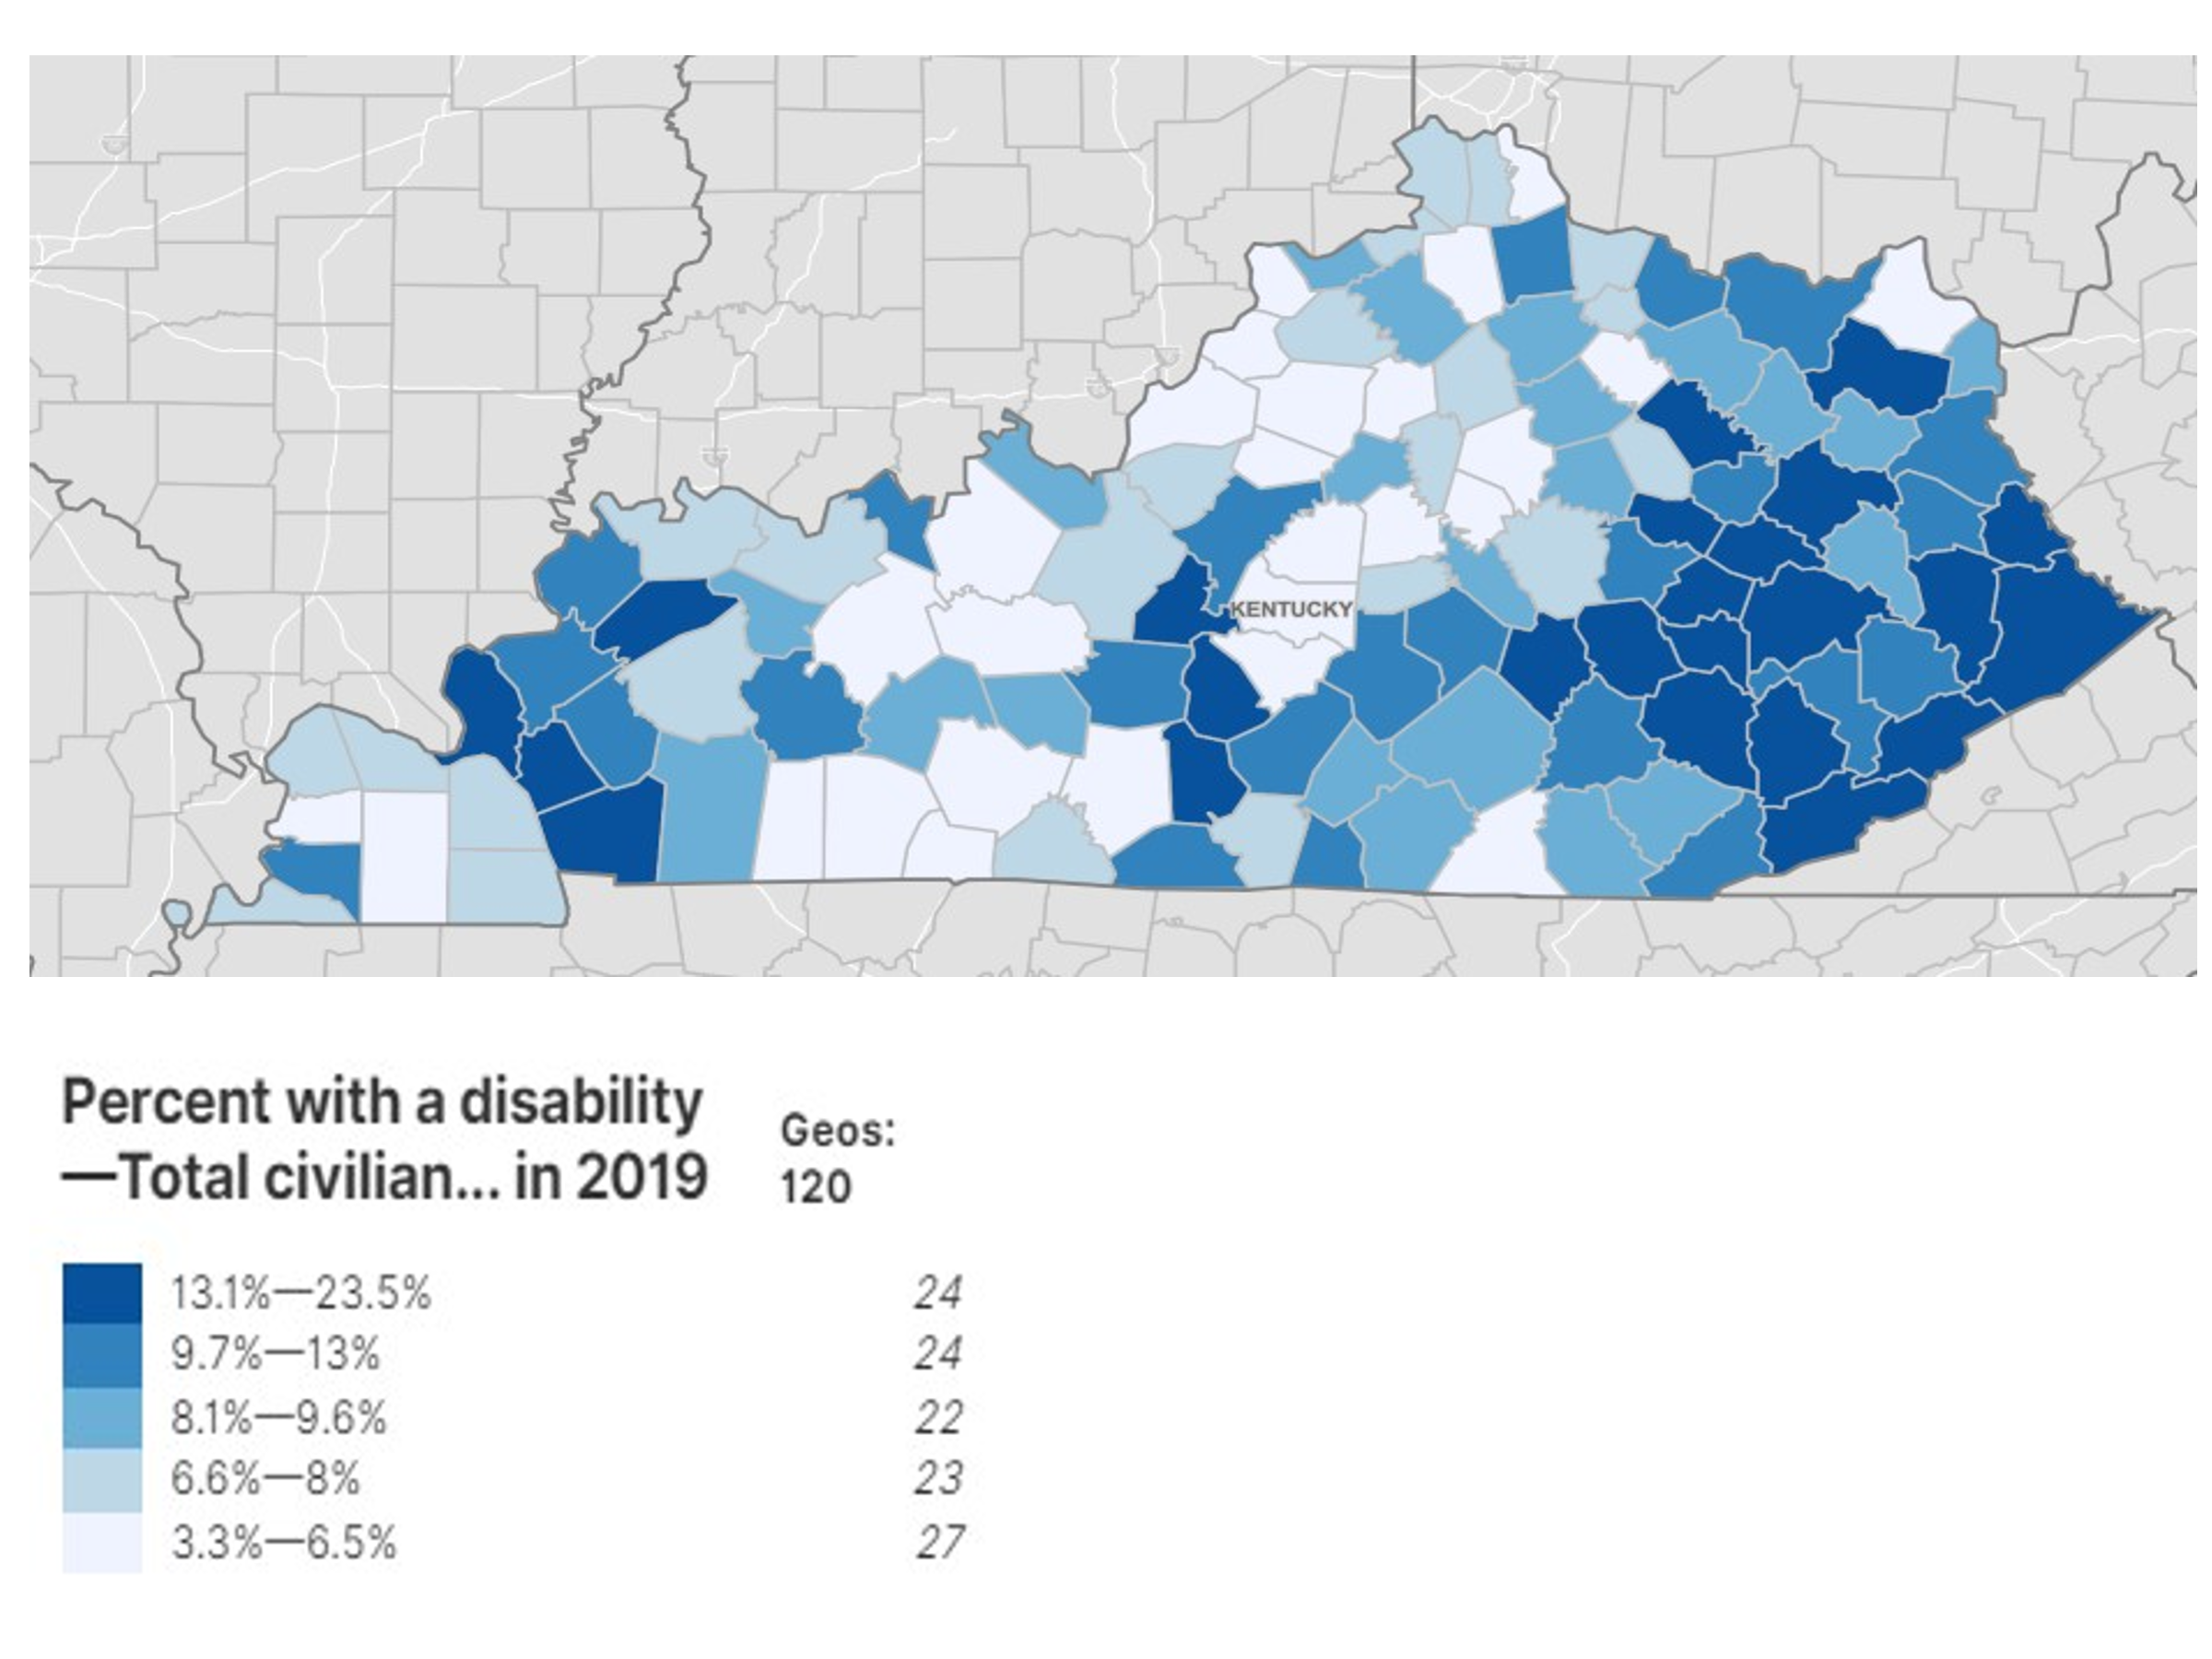
Note: See Appendix C for tabular representation of Figure 1.

Chronic Conditions

Older people with vision impairment in Kentucky are more likely to experience age-related chronic health conditions compared to people without vision impairment. See Figure 2. For example, 17% of people with vision impairment report having had a stroke compared to 10% among those without vision impairment. A stroke often compromises vision, but the effects of vision impairment from stroke are often unrecognized and under-appreciated. Diabetes is a known cause of vision impairment, and Kentucky data show that 32% of older people with vision impairment report diabetes compared to 26% of those without vision impairment. Older people with vision impairment in Kentucky are also more likely to report having had a heart attack (24%) compared to older people without vision impairment (13%). Because vision impairment often leads to compromised daily activities, older people with vision impairment more frequently report depression: 21% compared to 16% among older people without vision impairment. Moreover, people with vision impairment report more frequent hearing problems, with 38% reporting hearing impairment compared to 18% of people without vision impairment. Dual sensory impairment often has a compounding effect that leads to complex healthcare and rehabilitation needs. Vision and hearing are often addressed independently instead of in combination where interventions could be more effective.
Because vision is frequently required to recognize obstacles and trip hazards, 46% of older people with vision impairment in Kentucky report falling, compared to 31% of older people without vision impairment.⁹ Addressing falls risk among those with vision impairment could prevent complications of broken hip and functional decline.
In addition to heart attack, stroke, diabetes, and depression, the BRFSS asks about seven additional chronic conditions (asthma, cancer, COPD, arthritis, kidney disease, high cholesterol, and hypertension). In all cases, older people with vision impairment are more likely to report having these chronic conditions (Appendix B, Table 3.).
The sum of all these factors means that older people with vision impairment are at greater risk for losing independence.

Figure 2. Chronic Conditions among People with and without Vision Impairment, Kentucky, 2019, BRFSS
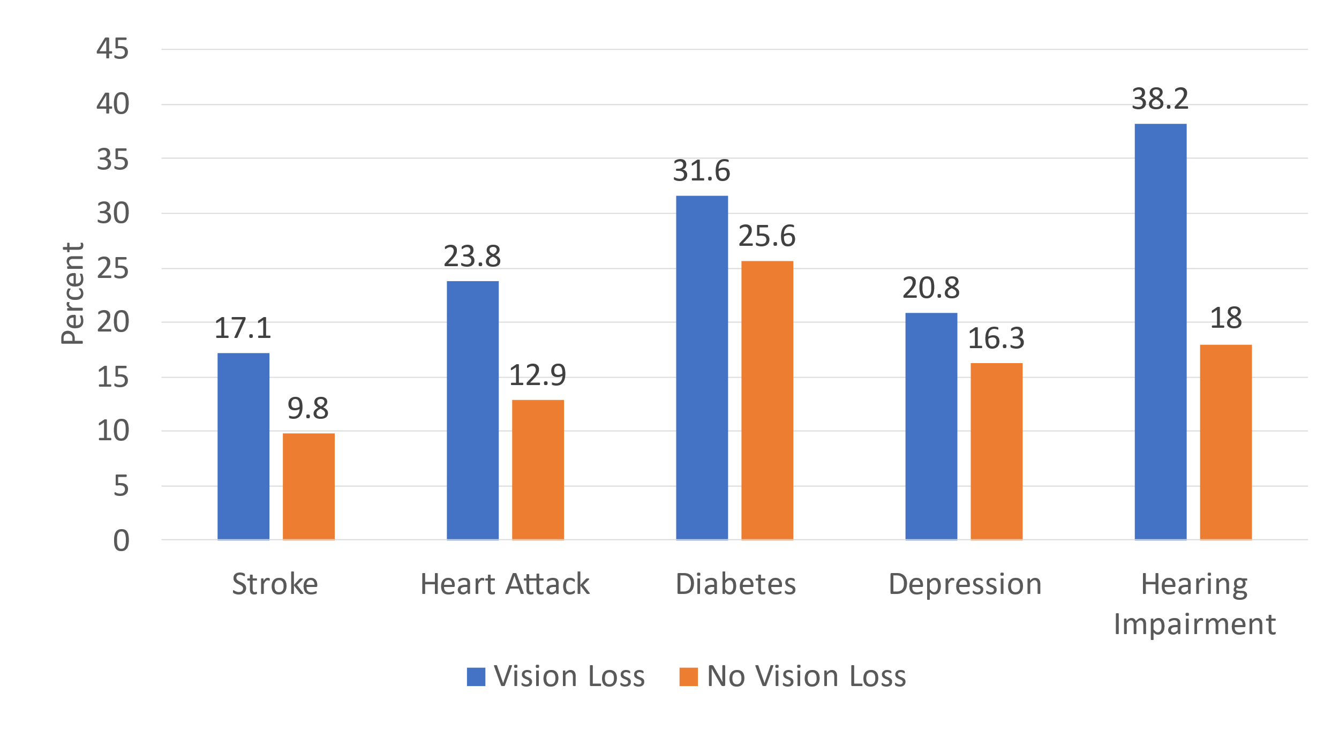

Note: See Appendix C for tabular representation of Figure 2.

Health-Related Quality of Life

BRFSS data show that older people with vision impairment compared to people without vision impairment are more likely to report poorer health-related quality of life. Four questions address health, physical distress, mental distress, and activity limitation in the Behavioral Risk Factor Surveillance System. This survey asks about self-reported health (excellent, very good, good, fair, and poor), how many days in the last 30 did the respondent report “health not good,” “mental health not good,” and “limitations in physical activity.” Figure 3 below illustrates the percent of people reporting 14 or more days out of the last 30 in which they experienced poor health, poor mental health, and activity limitations.
While 48% of people with vision impairment report fair or poor health, only 27% of older people without vision impairment report the same health status. Similarly, 41% of people with vision impairment report 14 or more days of physical health not good compared to 17% of those without vision impairment. Great differences are also found in frequent days of poor mental health; 14% of older people with vision impairment report frequent mentally unhealthy days compared to 7% among those without vision impairment. Not surprisingly, then, 30% of older people with vision impairment report frequent (14 or more) days of activity limitation compared to 20% among those without vision impairment.
Poorer health-related quality of life for older people with vision impairment in Kentucky likely results from many factors, including the effects of chronic conditions and the lack of vision rehabilitation services.

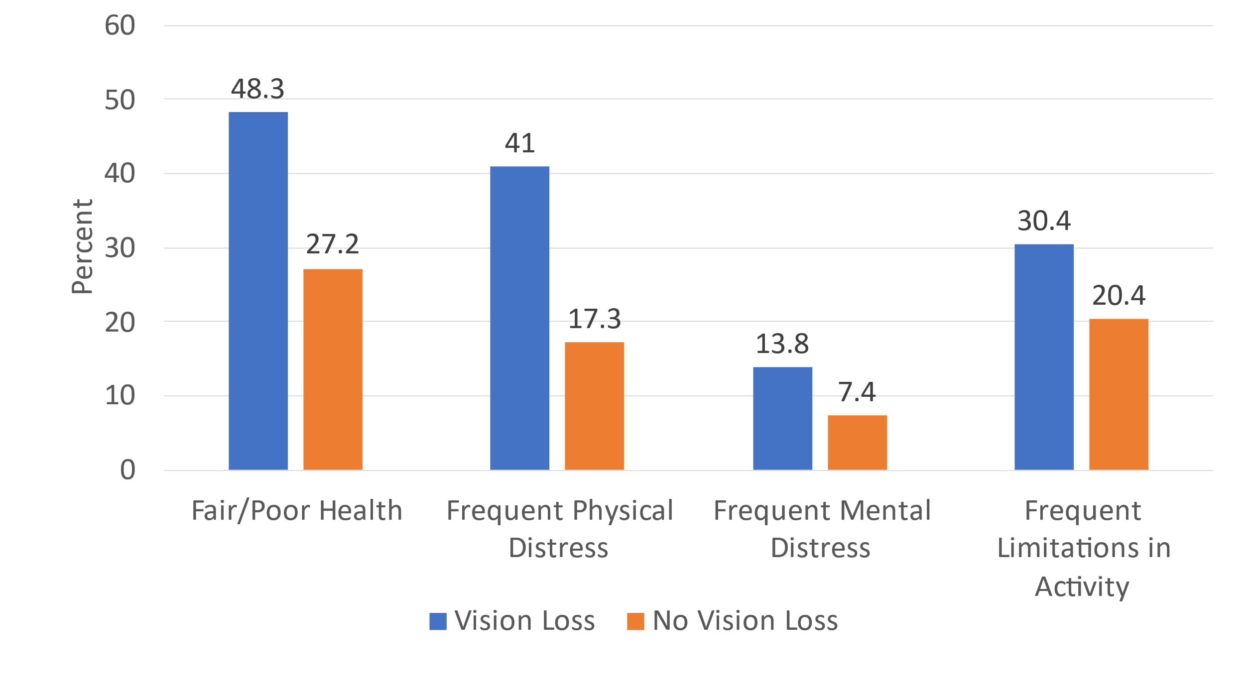
Figure 3. Health-Related Quality of Life among People Aged ≥65 Years, with and without Vision Impairment, Kentucky, 2019, BRFSS
Note: See Appendix C for tabular representation of Figure 3.

Disability Status

For many older people with vision impairment, multiple factors converge to threaten independence and quality of life. This report demonstrates that some groups are at greater risk of vision impairment than others, particularly African Americans and Hispanics, and those who are poorer and have less education. These upstream demographic factors may contribute to older people with vision impairment reporting higher prevalence of chronic conditions, including higher rates of diabetes, stroke, hearing impairment, and depression. These chronic health conditions in turn contribute to older people with vision impairment reporting poorer overall health and poorer health-related quality of life, including more frequent physically unhealthy days, more frequent mentally unhealthy days, and more frequent days of activity limitation. The convergence of these factors results in older people with vision impairment reporting greater disabilities, including limitations in cognitive function, walking and mobility, running errands, and dressing/bathing.
For older people, the effects of upstream factors appear to have dramatic effects on measures of disability. See Figure 4. While 26% of older people with vision impairment report difficulty concentrating and remembering,11% of people without vision impairment report problems with cognition. Substantial declines in cognitive function have been reported among people with vision impairment.¹⁰ Other measures of disability may represent the effects of the lack of vision rehabilitation services. Older people with vision impairment are more than twice as likely to report difficulty walking and climbing stairs (62% compared to 31%) compared to people without vision impairment. That limitation could be attributed to a lack of orientation and mobility training or a lack of low vision services and low vision aids. More dramatically, older people with vision impairment are almost four times as likely to report difficulty running errands (38% compared to 10%). That measure may reflect the combined effects of the lack of vision rehabilitation services that address travel skills and low vision services.

Figure 4. Disability Status among People Age ≥65 Years with and without Vision Impairment, Kentucky, 2019, BRFSS
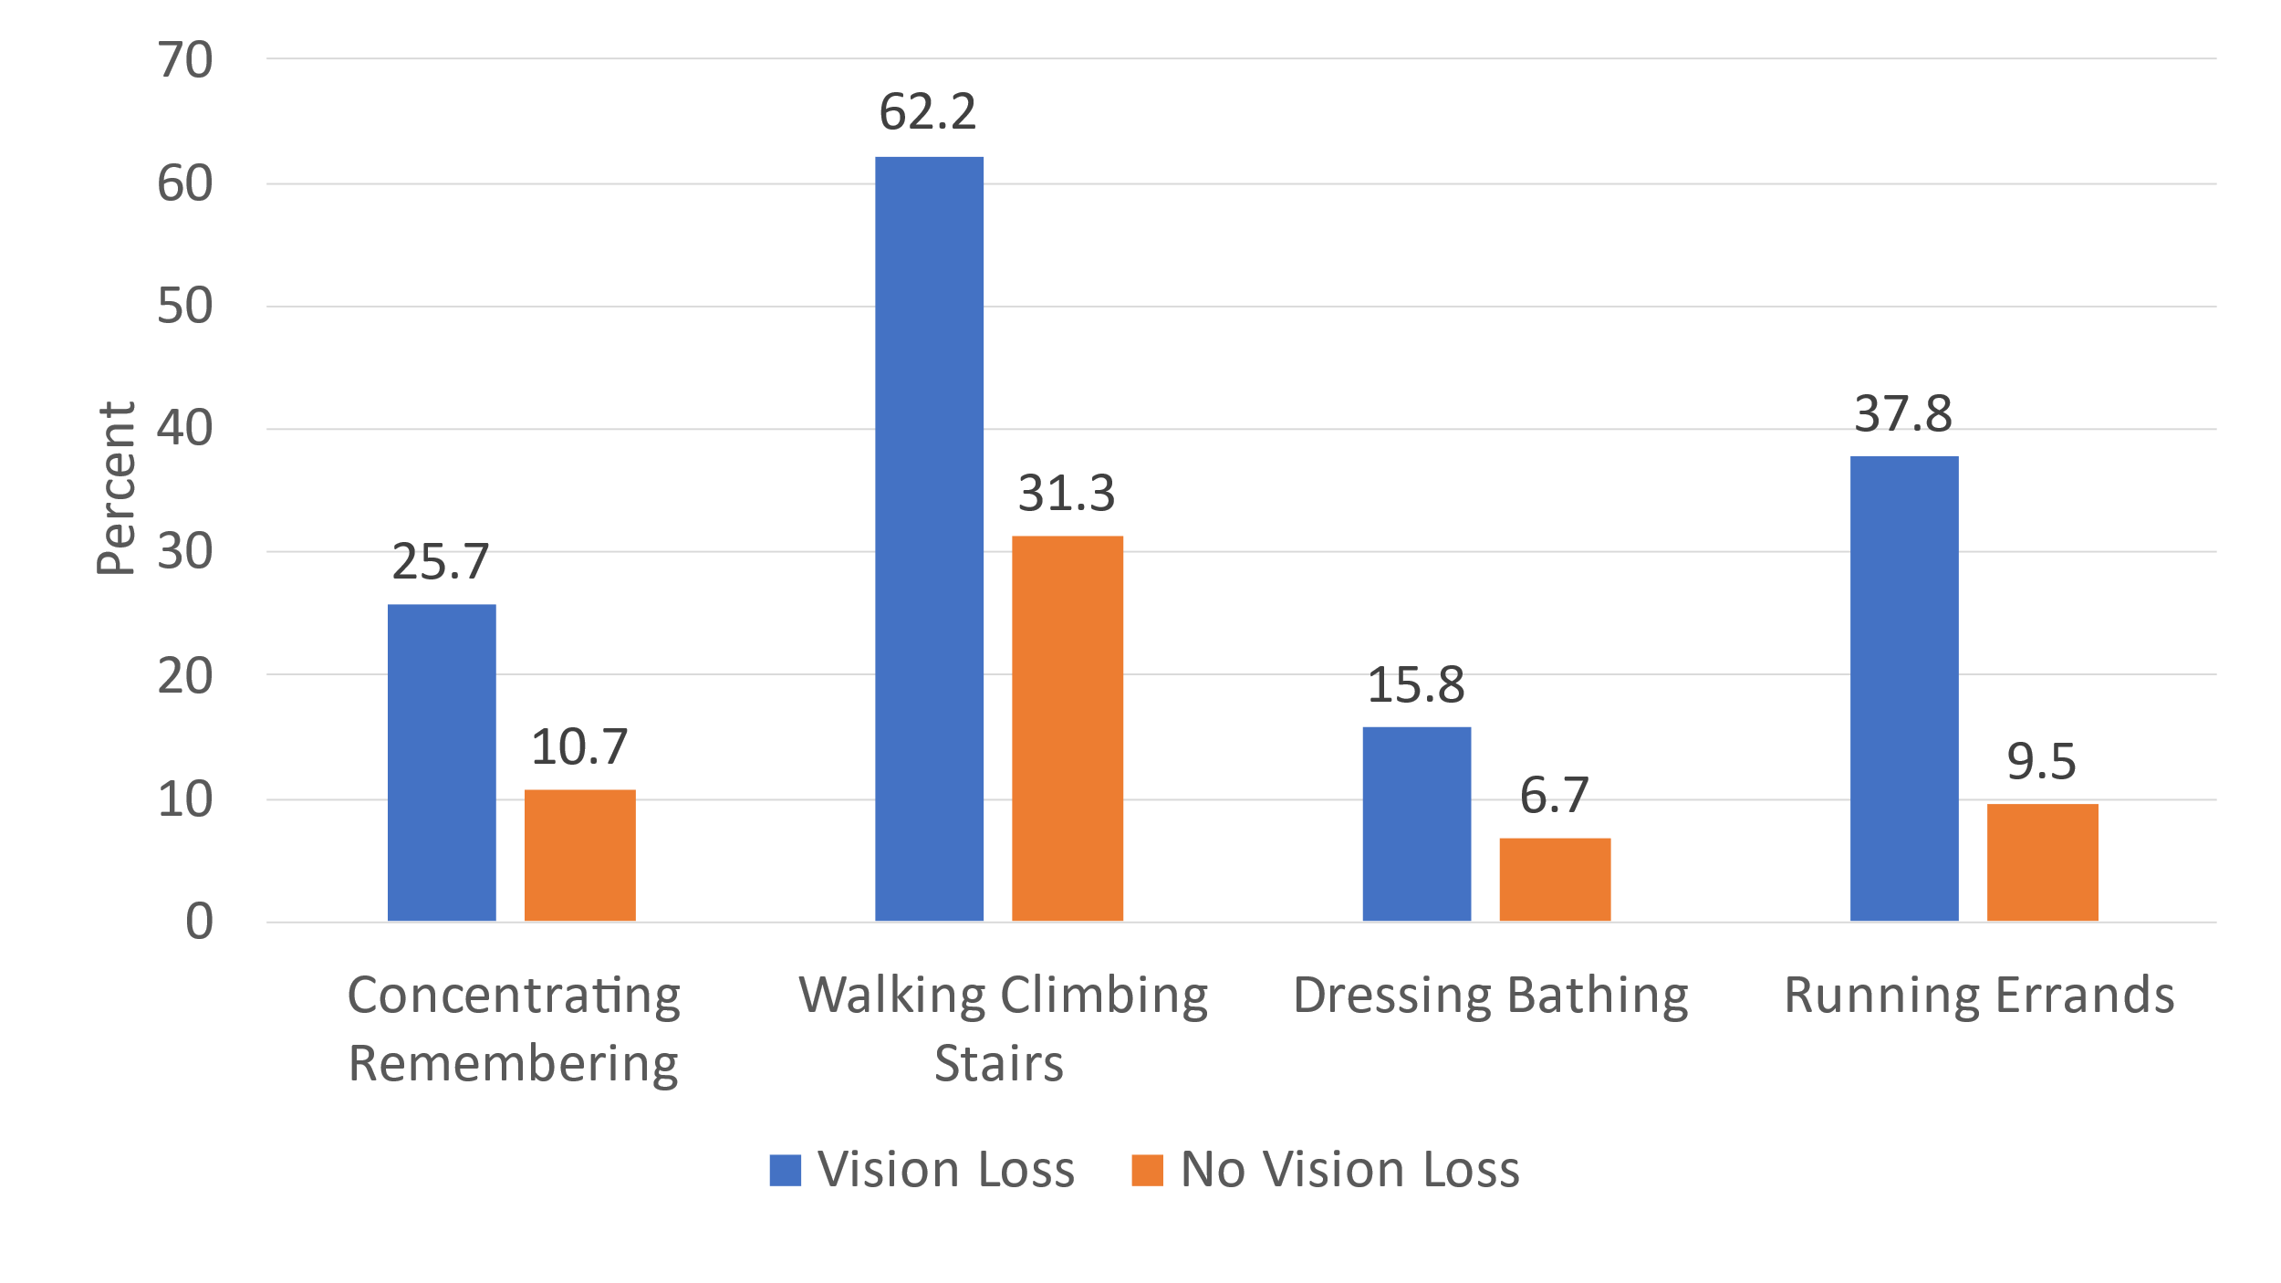

Note: See Appendix C for tabular representation of Figure 4.

Social Determinants of Health and Health Equity

Health inequities are shown to be related to social determinants of health based on sex, socio-economic status, race, ethnicity, and specific health conditions.¹¹ Overall, people with vision impairment, as this report demonstrates, are disadvantaged in multiple domains of poorer health, decreased quality of life, and increased disability. See Appendix B, Table 2.
One social determinant of health is defined by educational level which often predicts career and economic well-being. Among older people with vision impairment, 31% did not complete high school compared to 17% of people without vision impairment.
In addition, older people with vision impairment are much more likely to experience poverty and lower incomes than people without vision impairment. For example, 14% of older people with vision impairment report annual incomes of less than $10,000 compared to 6% of older people without vision impairment. Nine percent of older people with vision impairment report annual incomes between $10,000 and less than $15,000, compared to 7% of people without vision impairment. Ten percent of older people with vision impairment, compared to 8% of people without vision impairment, report an annual income of $15,000 to less than $20,000. Lower socio-economic status has also been shown to represent a substantial barrier to access to care for those with vision loss—those with the most need for care.
While people with or without vision impairment are likely to have health insurance and a regular doctor, more people with vision impairment report having to delay health care because of cost, 8% compared to 4% of people without vision impairment.

Discussion

The experience of vision impairment for older people is complex and multidimensional. This report estimates the population and distribution of older people with vision impairment in Kentucky, and it characterizes the population in terms of health, chronic conditions, health-related quality of life, and disability status—variables available from the Behavioral Risk Factor Surveillance System and the American Community Survey. These findings reveal that upstream circumstances related to poverty and poorer education create the potential of downstream outcomes in poorer overall health and quality of life as well as increased disability.
While this briefing provides considerable insight into health, chronic conditions, and quality of life factors at the population level, the report does not tell the personal stories of older people who have lost vision. It does not chronicle the isolation or struggle to find eye care or vision rehabilitation service providers. It does not describe the positive effects of vision rehabilitation or the power that older people feel when participating with peers to share their stories or solve common problems. That gap will be filled by others.

Conclusion

About 9.7% of people aged 65 years and older respond yes to the question “Are you blind or do you have severe difficulty seeing even when wearing glasses.” African Americans and people who are older, poorer, and less educated report higher prevalence of vision impairment. People who are older and visually impaired report higher prevalence of chronic conditions, poorer overall health, and poorer health- related quality of life. These factors appear associated with higher prevalence of disability indicators. These findings reveal that people with vision impairment are disadvantaged in multiple ways that place them at greater risk for compromised independence and autonomy. The findings in this report are designed to inform policy makers and providers about the circumstances of older people with vision impairment so that decisions and programs can be designed to better support older people with vision loss.

References

¹Varma, R., Vajaranant, T.S., Burkemper, B., Wu, S., Torres, M., Hsu, C., Choudhury, F. and McKean-Cowdin, R., 2016. Visual impairment and blindness in adults in the United States: demographic and geographic variations from 2015 to 2050. JAMA ophthalmology, 134(7), pp.802-809.
²Crews, J.E., Chou, C.F., Sekar, S. and Saaddine, J.B., 2017. The prevalence of chronic conditions and poor health among people with and without vision impairment, aged≥ 65 years, 2010–2014. American journal of ophthalmology, 182, pp.18-30.
³Crews, J.E., Chou, C.F., Stevens, J.A. and Saaddine, J.B., 2016. Falls among persons aged≥ 65 years with and without severe vision impairment—United States, 2014. Morbidity and Mortality Weekly Report, 65(17), pp.433-437.
⁴Crews, J.E., Chou, C.F., Naavaal, S., Griffin, S.O. and Saaddine, J.B., 2020. Self-Reported Oral Health Status Among Adults Aged 40+ Years With and Without Vision Impairment: National Health Interview Study, 2008. American journal of ophthalmology, 210, pp.184-191.
⁵Owsley, C. and McGwin, G., 2019. Bidirectionality of the Association of Vision Impairment with Depression and Anxiety. JAMA ophthalmology, 137(7), pp.801-801.
⁶Crews, J.E., Chou, C.F., Zhang, X., Zack, M.M. and Saaddine, J.B., 2014. Health-related quality of life among people aged≥ 65 years with self-reported visual impairment: findings from the 2006–2010 behavioral risk factor surveillance system. Ophthalmic epidemiology, 21(5), pp.287-296.
⁷Spencer, C., Frick, K., Gower, E.W., Kempen, J.H. and Wolff, J.L., 2009. Disparities in access to medical care for individuals with vision impairment. Ophthalmic epidemiology, 16(5), pp.281-288.
⁸National Academies of Sciences, Engineering, and Medicine. 2016. Making Eye Health a Population Health Imperative: Vision for Tomorrow. Washington, DC: The National Academies Press. https://doi.org/10.17226/23471.
⁹Crews, J.E., Chou, C.F., Stevens, J.A. and Saaddine, J.B., 2016. Falls among persons aged≥ 65 years with and without severe vision impairment—United States, 2014. Morbidity and Mortality Weekly Report, 65(17), pp.433-437.
¹⁰Nagarajan, N., Swenor, B., Assi, L., Ehrlich, J. and Whitson, H., 2020. A Systematic Review of Visual Impairment and Cognitive Decline Among Older Adults. Innovation in Aging, 4(Supplement_1), pp.529-530.
¹¹Ulldemolins, A.R., Lansingh, V.C., Valencia, L.G., Carter, M.J. and Eckert, K.A., 2012. Social inequalities in blindness and visual impairment: a review of social determinants. Indian journal of ophthalmology, 60(5), 368-375.

Acknowledgements

VisionServe Alliance gratefully acknowledges XXXXXXX

Appendix A: Methods

The Behavioral Risk Factor Surveillance System conducted by the U.S. Centers for Disease Control and Prevention (CDC) gathers health and health behavior data in each of the states and territories. Conducted since 1984, the BRFSS represents the world’s largest telephone survey, sampling over 440,000 people annually. For additional details, see BRFSS here. Data are collected from January to December using standard methods, and data are made publicly available about five months after data collection is completed. In 2013 the BRFSS added a standard set of disability questions to the core. The vision question asks, “Are you blind or do you have serious difficult seeing even while wearing glasses?” This question serves as the case definition of vision impairment for this study, and is the same question used by the American Community Survey in the Census data.
Using BRFSS data, it is possible to construct a profile of each state addressing demographic characteristics (age, sex, race/ethnicity, and education), reported chronic conditions (heart attack, coronary heart disease, stroke, COPD, diabetes, and arthritis), health-related quality of life (HRQoL), disability, and factors related to Social Determinants of Health among people with and without vision impairment. An analysis of these factors identifies the magnitude of within state disparities between people with and without vision impairment. Moreover, an analysis of aggregated national level BRFSS data allows for an understanding of how each state compares with national averages across these factors.
To account for the complex sampling weights used in the 2019 BRFSS survey, all analysis was run in SAS callable SUDAAN. To be included in the analysis subjects must be at least 65 years old and respond to both the vision impairment and age question. The response rate was 97.4%. The final sample size is 145,322. This includes 135,566 subjects without vision impairment and 9,756 subjects with vision impairment.
The American Community Survey (ACS) from the U.S. Census collects data on social, economic, and demographic characteristics, including housing, employment status, income/poverty, and level of education. In addition, the ACS collects data on race/ethnicity, sex, marital status, and living arrangements. Although the ACS does not collect information about health and health behaviors, it asks the same six disability questions as the BRFSS, including vision, hearing, cognition, walking, bathing, and doing errands. The function of the ACS is to provide information for decision makers to allocate federal resources. The granularity of the data makes it possible to construct county, state, and national profiles regarding social, economic, and demographic factors (see more ACS information here). The unique feature of the ACS is that the prevalence of vision impairment can be estimated at the county level, and maps can be constructed to illustrate the distribution of vision impairment within and across states.
The descriptive tables in the appendices show the estimated point prevalence as well as the 95% Confidence Interval (CI) for each variable. Ninety-five percent CI means that we are 95% certain that the true value resides with the estimated perimeters. Confidence intervals for many of the variables are wide in large part because the sample size is small. By combining multiple years of data, the CI would likely be reduced. Caution should be exercised in interpreting these findings.
Most all large population-based surveys are limited because they rely on self-reported information from survey respondents. Multiple questions regarding vision have been employed in national surveys, and each question yields a different population estimate.¹ The American Community Survey, for example, asks the question “Are you blind or do you have serious difficulty seeing even when wearing glasses?” The narrow focus of this question yields a low prevalence of vision impairment—about 7.3% among older people in the U.S. Another large population-based survey, the National Health Interview Survey, asks “Do you have any trouble seeing, even when wearing glasses or contact lenses?” That question yields an estimated prevalence of 13.5% among older people.² There is no widely accepted gold standard vision question used in national surveys. However, the BRFSS and ACS are the only surveys that provide state and county level estimates.
This report was prepared by the VanNasdale Lab at The Ohio State University College of Optometry. Questions regarding the methods and findings for this study should be directed to John E. Crews, DPA (johncrews@bellsouth.net) or Dean VanNasdale, OD, PhD (vannasdale.1@osu.edu).

¹Crews JE, Lollar DJ, Kemper AR, Lee LM, Owsley C, Zhang X, Elliott AF, Chou CF, Saaddine JB. 2012. The variability of vision loss assessment in federally sponsored surveys: Seeking conceptual clarity and comparability. American journal of ophthalmology, 154(6), pp.S31-S44.
²Blewett LA, Rivera Drew JA, Griffin R, King ML, Williams KC. 2016. National health interview survey, version 6.2. Minneapolis: University of Kentucky. Retrieved June, 16, p.2017.

Appendix B: BRFSS and ACS Tables

Appendix B, Table 1. Prevalence of Visual Impairment by Age and Race/Ethnicity in People Aged 65 and Older, BRFSS, United States and Kentucky, 2019

 | United States |  | Kentucky
 | % | 95% CI | % | 95% CI
Age
65+ years | 7.3% | 7.0- 7.6 | 9.7% | 8.2- 11.5
65-74 years | 6.3% | 6.0- 6.7 | 9.0% | 7.2- 11.2
75-79 years | 7.4% | 6.7- 8.1 | 7.6% | 4.5- 12.8
80+ years | 9.8% | 9.2- 10.5 | 14.0% | 10.4- 18.7
Sex
Male | 7.0% | 6.6- 7.5 | 9.5% | 7.5- 12.1
Female | 7.5% | 7.1- 7.9 | 9.8% | 7.7- 12.4
Marital Status
Married | 5.7% | 5.3- 6.1 | 8.3% | 6.3- 10.8
Not Married/Separated | 9.3% | 8.8- 9.8 | 11.5% | 9.3- 14.3
Education
Did not graduate High School | 15.4% | 14.0- 17.0 | 16.3% | 11.4- 22.8
Graduated High School | 7.4% | 6.9- 7.9 | 9.4% | 7.1- 12.3
Attended College or Technical School | 6.6% | 6.1- 7.1 | 9.4% | 6.7- 12.9
Graduated from College or Technical | 4.0% | 3.6- 4.4 | 4.7% | 2.9- 7.4
Race/Ethnicity
White only, non-Hispanic | 6.1% | 5.8- 6.4 | 9.3% | 7.8- 11.1
Black only, non-Hispanic | 10.5% | 9.4- 11.7 | 12.1% | 5.7- 24.0
American Indian or Alaskan Native only, non-Hispanic | 14.2% | 10.0- 19.8 | ---* | ---*
Asian only, non-Hispanic | 8.8% | 6.0- 12.8 | ---* | ---*
Hispanic | 13.9% | 11.9- 16.2 | ---* | ---*

*Sample size is too small to make reliable estimates.

Appendix B, Table 2. Prevalence of Vision Impairment among People Age ≥65 Years by County, Kentucky, American Community Survey, 2019

County | Percent
Adair County, Kentucky | 10
Allen County, Kentucky | 7.7
Anderson County, Kentucky | 8.8
Ballard County, Kentucky | 7.1
Barren County, Kentucky | 5.9
Bath County, Kentucky | 16.6
Bell County, Kentucky | 12.4
Boone County, Kentucky | 7.2
Bourbon County, Kentucky | 8.5
Boyd County, Kentucky | 8.9
Boyle County, Kentucky | 7.9
Bracken County, Kentucky | 6.8
Breathitt County, Kentucky | 20.8
Breckinridge County, Kentucky | 4.7
Bullitt County, Kentucky | 8
Butler County, Kentucky | 9.4
Caldwell County, Kentucky | 12.2
Calloway County, Kentucky | 8
Campbell County, Kentucky | 4.5
Carlisle County, Kentucky | 5.6
Carroll County, Kentucky | 9.2
Carter County, Kentucky | 13.1
Casey County, Kentucky | 10.2
Christian County, Kentucky | 8.9
Clark County, Kentucky | 8.1
Clay County, Kentucky | 15.2
Clinton County, Kentucky | 12.9
Crittenden County, Kentucky | 12.1
Cumberland County, Kentucky | 7.3
Daviess County, Kentucky | 7.4
Edmonson County, Kentucky | 8.1
Elliott County, Kentucky | 9.1
Estill County, Kentucky | 9.7
Fayette County, Kentucky | 6.2
Fleming County, Kentucky | 9
Floyd County, Kentucky | 16.7
Franklin County, Kentucky | 6.2
Fulton County, Kentucky | 7.6
Gallatin County, Kentucky | 6.8
Garrard County, Kentucky | 8.4
Grant County, Kentucky | 5.6
Graves County, Kentucky | 6.5
Grayson County, Kentucky | 6.2
Green County, Kentucky | 13.2
Greenup County, Kentucky | 6.4
Hancock County, Kentucky | 12.8
Hardin County, Kentucky | 7.3
Harlan County, Kentucky | 19.1
Harrison County, Kentucky | 9.2
Hart County, Kentucky | 10.6
Henderson County, Kentucky | 7.9
Henry County, Kentucky | 6.9
Hickman County, Kentucky | 11.7
Hopkins County, Kentucky | 7.8
Jackson County, Kentucky | 20.8
Jefferson County, Kentucky | 5.7
Jessamine County, Kentucky | 6.3
Johnson County, Kentucky | 10.4
Kenton County, Kentucky | 6.8
Knott County, Kentucky | 9.9
Knox County, Kentucky | 9.4
Larue County, Kentucky | 13.3
Laurel County, Kentucky | 11
Lawrence County, Kentucky | 10
Lee County, Kentucky | 21.8
Leslie County, Kentucky | 15.8
Letcher County, Kentucky | 15.4
Lewis County, Kentucky | 10
Lincoln County, Kentucky | 9.7
Livingston County, Kentucky | 13.7
Logan County, Kentucky | 3.3
Lyon County, Kentucky | 23.5
McCracken County, Kentucky | 7.1
McCreary County, Kentucky | 6.5
McLean County, Kentucky | 8.3
Madison County, Kentucky | 7
Magoffin County, Kentucky | 9.4
Marion County, Kentucky | 5.9
Marshall County, Kentucky | 7.7
Martin County, Kentucky | 22.7
Mason County, Kentucky | 10.8
Meade County, Kentucky | 9.1
Menifee County, Kentucky | 11.3
Mercer County, Kentucky | 5.3
Metcalfe County, Kentucky | 13.6
Monroe County, Kentucky | 11.7
Montgomery County, Kentucky | 7.6
Morgan County, Kentucky | 14.4
Muhlenberg County, Kentucky | 11.6
Nelson County, Kentucky | 9.9
Nicholas County, Kentucky | 6.4
Ohio County, Kentucky | 4.5
Oldham County, Kentucky | 4.6
Owen County, Kentucky | 8.1
Owsley County, Kentucky | 23.3
Pendleton County, Kentucky | 11.8
Perry County, Kentucky | 12.5
Pike County, Kentucky | 13.3
Powell County, Kentucky | 17.2
Pulaski County, Kentucky | 8.6
Robertson County, Kentucky | 7.1
Rockcastle County, Kentucky | 14.6
Rowan County, Kentucky | 8.1
Russell County, Kentucky | 8.9
Scott County, Kentucky | 7
Shelby County, Kentucky | 4.4
Simpson County, Kentucky | 3.4
Spencer County, Kentucky | 4.3
Taylor County, Kentucky | 4.9
Todd County, Kentucky | 6.5
Trigg County, Kentucky | 13.2
Trimble County, Kentucky | 4.8
Union County, Kentucky | 10.4
Warren County, Kentucky | 5.5
Washington County, Kentucky | 4.9
Wayne County, Kentucky | 8.3
Webster County, Kentucky | 13.7
Whitley County, Kentucky | 9.3
Wolfe County, Kentucky | 18.4
Woodford County, Kentucky | 7.7

Distribution of Population of People Aged ≥65 Years with Vision Impairment by County by Quintiles, Kentucky, American Community Survey, 2019.

County | Percent
5th Quintile
Lyon County, Kentucky | 23.5
Owsley County, Kentucky | 23.3
Martin County, Kentucky | 22.7
Lee County, Kentucky | 21.8
Breathitt County, Kentucky | 20.8
Jackson County, Kentucky | 20.8
Harlan County, Kentucky | 19.1
Wolfe County, Kentucky | 18.4
Powell County, Kentucky | 17.2
Floyd County, Kentucky | 16.7
Bath County, Kentucky | 16.6
Leslie County, Kentucky | 15.8
Letcher County, Kentucky | 15.4
Clay County, Kentucky | 15.2
Rockcastle County, Kentucky | 14.6
Morgan County, Kentucky | 14.4
Livingston County, Kentucky | 13.7
Webster County, Kentucky | 13.7
Metcalfe County, Kentucky | 13.6
Larue County, Kentucky | 13.3
Pike County, Kentucky | 13.3
Green County, Kentucky | 13.2
Trigg County, Kentucky | 13.2
Carter County, Kentucky | 13.1
4th Quintile
Clinton County, Kentucky | 12.9
Hancock County, Kentucky | 12.8
Perry County, Kentucky | 12.5
Bell County, Kentucky | 12.4
Caldwell County, Kentucky | 12.2
Crittenden County, Kentucky | 12.1
Pendleton County, Kentucky | 11.8
Hickman County, Kentucky | 11.7
Monroe County, Kentucky | 11.7
Muhlenberg County, Kentucky | 11.6
Menifee County, Kentucky | 11.3
Laurel County, Kentucky | 11
Mason County, Kentucky | 10.8
Hart County, Kentucky | 10.6
Johnson County, Kentucky | 10.4
Union County, Kentucky | 10.4
Casey County, Kentucky | 10.2
Adair County, Kentucky | 10
Lawrence County, Kentucky | 10
Lewis County, Kentucky | 10
Knott County, Kentucky | 9.9
Nelson County, Kentucky | 9.9
Estill County, Kentucky | 9.7
Lincoln County, Kentucky | 9.7
3rd Quintile
Butler County, Kentucky | 9.4
Knox County, Kentucky | 9.4
Magoffin County, Kentucky | 9.4
Whitley County, Kentucky | 9.3
Carroll County, Kentucky | 9.2
Harrison County, Kentucky | 9.2
Elliott County, Kentucky | 9.1
Meade County, Kentucky | 9.1
Fleming County, Kentucky | 9
Boyd County, Kentucky | 8.9
Christian County, Kentucky | 8.9
Russell County, Kentucky | 8.9
Anderson County, Kentucky | 8.8
Pulaski County, Kentucky | 8.6
Bourbon County, Kentucky | 8.5
Garrard County, Kentucky | 8.4
McLean County, Kentucky | 8.3
Wayne County, Kentucky | 8.3
Clark County, Kentucky | 8.1
Edmonson County, Kentucky | 8.1
Owen County, Kentucky | 8.1
Rowan County, Kentucky | 8.1
2nd Quintile
Bullitt County, Kentucky | 8
Calloway County, Kentucky | 8
Boyle County, Kentucky | 7.9
Henderson County, Kentucky | 7.9
Hopkins County, Kentucky | 7.8
Allen County, Kentucky | 7.7
Marshall County, Kentucky | 7.7
Woodford County, Kentucky | 7.7
Fulton County, Kentucky | 7.6
Montgomery County, Kentucky | 7.6
Daviess County, Kentucky | 7.4
Cumberland County, Kentucky | 7.3
Hardin County, Kentucky | 7.3
Boone County, Kentucky | 7.2
Ballard County, Kentucky | 7.1
McCracken County, Kentucky | 7.1
Robertson County, Kentucky | 7.1
Madison County, Kentucky | 7
Scott County, Kentucky | 7
Henry County, Kentucky | 6.9
Bracken County, Kentucky | 6.8
Gallatin County, Kentucky | 6.8
Kenton County, Kentucky | 6.8
1st Quintile
Graves County, Kentucky | 6.5
McCreary County, Kentucky | 6.5
Todd County, Kentucky | 6.5
Greenup County, Kentucky | 6.4
Nicholas County, Kentucky | 6.4
Jessamine County, Kentucky | 6.3
Fayette County, Kentucky | 6.2
Franklin County, Kentucky | 6.2
Grayson County, Kentucky | 6.2
Barren County, Kentucky | 5.9
Marion County, Kentucky | 5.9
Jefferson County, Kentucky | 5.7
Carlisle County, Kentucky | 5.6
Grant County, Kentucky | 5.6
Warren County, Kentucky | 5.5
Mercer County, Kentucky | 5.3
Taylor County, Kentucky | 4.9
Washington County, Kentucky | 4.9
Trimble County, Kentucky | 4.8
Breckinridge County, Kentucky | 4.7
Oldham County, Kentucky | 4.6
Campbell County, Kentucky | 4.5
Ohio County, Kentucky | 4.5
Shelby County, Kentucky | 4.4
Spencer County, Kentucky | 4.3
Simpson County, Kentucky | 3.4
Logan County, Kentucky | 3.3

Appendix B, Table 3. Social, Economic, and Health Characteristics of People Age ≥65 Years United States and Kentucky, 2019, BRFSS

 | United States |  |  |  | Kentucky
 | Blind N=9,756 |  | Not Blind N=135,566 |  | Blind N=260 |  | Not Blind N=2,473
 | % | 95% CI | % | 95% CI | % | 95% CI | % | 95% CI
Age Group
65-74 years | 51.3 | 49.1- 53.4 | 59.6 | 59.0- 60.1 | 56.3 | 47.2- 64.9 | 61.4 | 58.3- 64.4
75-79 years | 19.6 | 17.9- 21.5 | 19.4 | 18.9- 19.8 | 15.4 | 9.2- 24.6 | 20 | 17.6- 22.6
80+ years | 29.1 | 27.3- 31.0 | 21 | 20.6- 21.5 | 28.4 | 21.4- 36.5 | 18.7 | 16.2- 21.4
Sex
Male | 43.4 | 41.2- 45.6 | 45.1 | 44.5- 45.6 | 44 | 35.5- 52.8 | 44.9 | 41.8- 48.0
Female | 56.6 | 54.4- 58.8 | 54.9 | 54.4- 55.5 | 56 | 47.2- 64.5 | 55.1 | 52.0- 58.2
Marital Status
Married | 42.9 | 40.7- 45.1 | 56.3 | 55.7- 56.8 | 47.8 | 39.0- 56.8 | 56.9 | 53.8- 60.0
Not Married/Separated | 57.1 | 54.9- 59.3 | 43.7 | 43.2- 44.3 | 52.2 | 43.2- 61.0 | 43.1 | 40.0- 46.2
Education
Did not graduate High School | 28.7 | 26.4- 31.1 | 12.4 | 11.9- 12.8 | 30.9 | 22.7- 40.5 | 17 | 14.4- 20.0
Graduated High School | 28.5 | 26.7- 30.3 | 28.2 | 27.7- 28.7 | 33.4 | 25.9- 41.9 | 34.6 | 31.7- 37.6
Attended College or Technical School | 27.9 | 26.0- 29.8 | 31.1 | 30.6- 31.6 | 25.7 | 18.9- 34.1 | 26.8 | 24.2- 29.5
Graduated from College or Technical | 15 | 13.7- 16.4 | 28.4 | 27.9- 28.8 | 9.9 | 6.2- 15.5 | 21.6 | 19.5- 23.9
Race/Ethnicity
White only, non-Hispanic | 65 | 62.5- 67.3 | 79 | 78.4- 79.6 | 89.6 | 81.3- 94.4 | 93.6 | 92.0- 94.9
Black only, non-Hispanic | 12.8 | 11.5- 14.3 | 8.6 | 8.3- 9.0 | 6.6 | 3.1- 13.7 | 5.1 | 3.9- 6.7
American Indian or Alaskan Native only, non-Hispanic | 1.9 | 1.3- 2.7 | 0.9 | 0.8- 1.0 | 1.2 | 0.2- 6.5 | 0.4 | 0.2- 0.9
Asian only, non-Hispanic | 3 | 2.0- 4.4 | 2.4 | 2.1- 2.8 | 0.2 | 0.0- 1.1 | 0.1 | 0.0- 0.3
Hispanic | 15.3 | 13.1- 17.6 | 7.4 | 7.0- 7.9 | 2 | 0.3- 12.1 | 0.4 | 0.2- 0.9
Annual Income
Less than $10,000 | 10.6 | 9.1- 12.3 | 3.6 | 3.3- 3.9 | 13.5 | 6.9- 24.9 | 6.3 | 4.5- 8.7
$10,000 to less than $15,000 | 11.7 | 10.3- 13.3 | 5.4 | 5.1- 5.7 | 8.6 | 4.7- 15.3 | 6.6 | 5.0- 8.7
$15,000 to less than $20,000 | 14.8 | 13.2- 16.5 | 7.9 | 7.6- 8.3 | 10.1 | 5.7- 17.1 | 8.1 | 5.8- 11.2
$20,000 to less than $25,000 | 13.5 | 12.0- 15.2 | 10.7 | 10.3- 11.1 | 13.7 | 7.2- 24.7 | 9.2 | 6.9- 12.2
$25,000 to less than $35,000 | 14.4 | 12.8- 16.0 | 12.7 | 12.3- 13.1 | 19.9 | 10.8- 33.5 | 14.2 | 11.6- 17.3
$35,000 to less than $50,000 | 12.8 | 11.4- 14.5 | 15.9 | 15.4- 16.3 | 7.6 | 4.3- 13.3 | 15.2 | 12.6- 18.1
$50,000 to less than $75,000 | 9.8 | 8.5- 11.2 | 16.5 | 16.1- 17.0 | 14.9 | 7.2- 28.4 | 17.5 | 14.6- 20.8
$75,000 or more | 12.4 | 10.7- 14.3 | 27.3 | 26.7- 27.8 | 11.7 | 6.3- 20.6 | 23 | 20.0- 26.3
Health Behaviors
BMI
Underweight | 2.6 | 2.1- 3.3 | 1.8 | 1.7- 2.0 | 1.6 | 0.5- 4.9 | 1.6 | 0.9- 2.9
Normal weight | 27.3 | 25.5- 29.2 | 30.5 | 30.0- 31.1 | 28.4 | 20.5- 38.0 | 26.5 | 23.8- 29.5
Overweight | 37.2 | 35.0- 39.5 | 38.6 | 38.1- 39.2 | 33.7 | 26.0- 42.4 | 39.5 | 36.5- 42.5
Obese | 32.9 | 30.8- 35.1 | 29 | 28.5- 29.6 | 36.3 | 28.0- 45.5 | 32.4 | 29.5- 35.4
Physical Exercise | 53.6 | 51.4- 55.8 | 70.2 | 69.7- 70.7 | 47 | 38.2- 55.9 | 59.7 | 56.6- 62.8
Smoking Status
Current smoker | 13.4 | 12.0- 14.9 | 8.8 | 8.4- 9.1 | 17.4 | 11.3- 25.8 | 11.6 | 9.7- 13.8
Former smoker | 40.8 | 38.6- 43.0 | 39.8 | 39.2- 40.3 | 33.1 | 25.3- 42.1 | 38 | 35.1- 41.1
Never smoked | 45.8 | 43.6- 48.0 | 51.5 | 50.9- 52.0 | 49.5 | 40.5- 58.4 | 50.4 | 47.3- 53.5
Health Care Access
Have Health Insurance | 96 | 95.0- 96.8 | 98.1 | 97.9- 98.2 | 95.6 | 89.1- 98.3 | 98.6 | 97.4- 99.2
Have Personal Doctor | 92.4 | 91.0- 93.6 | 93.8 | 93.5- 94.1 | 92.3 | 85.5- 96.1 | 94.7 | 93.1- 95.9
Could not see doctor because of cost. | 11.5 | 10.2- 12.9 | 4.2 | 4.0- 4.5 | 7.6 | 4.4- 12.8 | 3.8 | 2.8- 5.0
Health-Related Quality of Life
Adults with fair/poor health status | 51.4 | 49.2- 53.6 | 23.3 | 22.8- 23.8 | 48.3 | 39.5- 57.3 | 27.2 | 24.5- 30.1
14 or more days during past 30 when physical health not good. | 35.6 | 33.5- 37.8 | 15.9 | 15.5- 16.4 | 41 | 32.2- 50.3 | 17.3 | 15.0- 19.8
14 or more days during past 30 when mental health not good. | 17.9 | 16.3- 19.6 | 7.3 | 7.0- 7.6 | 13.8 | 8.9- 20.9 | 7.4 | 5.9- 9.2
14 or more days of activity limitation. | 34.3 | 31.8- 36.9 | 18.9 | 18.3- 19.5 | 30.4 | 21.3- 41.4 | 20.4 | 17.0- 24.3
Chronic Conditions
High Blood Pressure | 68.6 | 66.5- 70.7 | 59.7 | 59.1- 60.2 | 75.2 | 67.2- 81.7 | 66.7 | 63.7- 69.5
High Cholesterol | 56.6 | 54.4- 58.8 | 50.5 | 49.9- 51.1 | 62.7 | 53.5- 71.0 | 53.8 | 50.7- 56.9
Myocardial Infarction | 17.2 | 15.8- 18.7 | 10.2 | 9.9- 10.6 | 23.8 | 16.4- 33.1 | 12.9 | 11.0- 15.1
Angina or coronary heart disease | 18.2 | 16.4- 20.0 | 10.1 | 9.8- 10.5 | 25.5 | 17.5- 35.7 | 11.4 | 9.7- 13.4
Stroke | 16.9 | 15.3- 18.6 | 7.3 | 7.0- 7.6 | 17.1 | 11.2- 25.1 | 9.8 | 8.0- 11.9
Asthma | 18.2 | 16.6- 20.1 | 11.8 | 11.4- 12.1 | 15.5 | 10.0- 23.4 | 10.7 | 8.9- 12.7
Cancer | 32.7 | 30.7- 34.7 | 31.8 | 31.3- 32.4 | 33.1 | 25.3- 41.9 | 34.1 | 31.3- 37.1
COPD | 22.9 | 21.3- 24.7 | 12.2 | 11.8- 12.5 | 35.3 | 26.9- 44.8 | 17.6 | 15.3- 20.2
Arthritis | 61.3 | 59.1- 63.4 | 49.5 | 48.9- 50.1 | 69.9 | 61.4- 77.3 | 55 | 51.9- 58.1
Depression | 26.9 | 25.0- 29.0 | 13.9 | 13.5- 14.3 | 20.8 | 15.0- 28.1 | 16.3 | 14.3- 18.6
Kidney disease | 13.6 | 12.1- 15.3 | 6.4 | 6.1- 6.7 | 18.5 | 12.2- 26.9 | 7.4 | 6.0- 9.1
Diabetes | 36.4 | 34.2- 38.6 | 22.1 | 21.6- 22.6 | 31.6 | 23.7- 40.7 | 25.6 | 22.9- 28.4
Disability Status
Serious difficulty concentrating, remembering, or making decisions | 29.3 | 27.3- 31.4 | 8.2 | 7.9- 8.5 | 25.7 | 18.5- 34.6 | 10.7 | 9.1- 12.6
Serious difficulty walking or climbing stairs | 56.9 | 54.7- 59.0 | 25.4 | 24.9- 25.9 | 62.2 | 53.4- 70.3 | 31.3 | 28.5- 34.2
Difficulty dressing or bathing | 19.1 | 17.4- 20.8 | 5 | 4.8- 5.3 | 15.8 | 10.1- 24.0 | 6.7 | 5.3- 8.4
Difficulty doing errands alone | 35.3 | 33.3- 37.5 | 7.7 | 7.4- 8.0 | 37.8 | 29.4- 47.0 | 9.5 | 7.9- 11.4
Deaf or do you have serious difficulty hearing | 33.3 | 31.3- 35.3 | 15 | 14.6- 15.4 | 38.2 | 30.1- 47.1 | 18 | 15.6- 20.5

Appendix C: Tabular Representations of Figures 1-4

Figure 1. Estimated Prevalence of Vision Impairment among People Aged ≥65 Years by County, Kentucky, American Community Survey, 2019

Quintile | Number of Counties | Counties Included (total = 120)  (listed from high to low in each quintile)
13.1%-23.5% | 24 | Lyon, Owsley, Martin, Lee, Breathitt, Jackson, Harlan, Wolfe, Powell, Floyd, Bath, Leslie, Letcher, Clay, Rockcastle, Morgan, Livingston, Webster, Metcalfe, Larue, Pike, Green, Trigg, Carter
9.7%-13% | 24 | Clinton, Hancock, Perry, Bell, Caldwell, Crittenden, Pendleton, Hickman, Monroe, Muhlenberg, Menifee, Laurel, Mason, Hart, Johnson, Union, Casey, Adair, Lawrence, Lewis, Knott, Nelson, Estill, Lincoln
8.1%-9.6% | 22 | Butler, Knox, Magoffin, Whitley, Carroll, Harrison, Elliott, Meade, Fleming, Boyd, Christian, Russell, Anderson, Pulaski, Bourbon, Garrard, McLean, Wayne, Clark, Edmonson, Owen, Rowan
6.6%-8% | 23 | Bullitt, Calloway, Boyle, Henderson, Hopkins, Allen, Marshall, Woodford, Fulton, Montgomery, Daviess, Cumberland, Hardin, Boone, Ballard, McCracken, Robertson, Madison, Scott, Henry, Bracken, Gallatin, Kenton
3.3%-6.5% | 27 | Graves, McCreary, Todd, Greenup, Nicholas, Jessamine, Fayette, Franklin, Grayson, Barren, Marion, Jefferson, Carlisle, Grant, Warren, Mercer, Taylor, Washington, Trimble, Breckinridge, Oldham, Campbell, Ohio, Shelby, Spencer, Simpson, Logan

Figure 2. Chronic Conditions among People Aged ≥65 Years with and without Vision Impairment, Kentucky, 2019, BRFSS

Chronic Condition | Vision Impairment | No Vision  Impairment
Stroke | 17.1% | 9.8%
Heart Attack | 23.8% | 12.9%
Diabetes | 31.6% | 25.6%
Depression | 20.8% | 16.3%
Hearing Impairment | 38.2% | 18.0%

Figure 3. Health-Related Qualify of Life among People Aged ≥65 Years with and without Vision Impairment, Kentucky, 2019, BRFSS

Health-Related Quality of Life | Vision  Impairment | No Vision Impairment
Fair/Poor Health | 48.3% | 27.2%
Frequent Physical Distress | 41.0% | 17.3%
Frequent Mental Distress | 13.8% | 7.4%
Frequent Limitations in Activity | 30.4% | 20.4%

Figure 4. Disability Status among People Aged ≥65 Years, with and without Vision Impairment, Kentucky, 2019, BRFSS

Disability Status | Vision  Impairment | No Vision Impairment
Concentrating, Remembering | 25.7% | 10.7%
Walking, Climbing Stairs | 62.2% | 31.3%
Dressing, Bathing | 15.8% | 6.7%
Running Errands | 37.8% | 9.5%

Appendix D: Vision Rehabilitation Resources

