Vision Impairment and Vision Rehabilitation in the Lives of Older People in the United States
  - By VisionServe Alliance
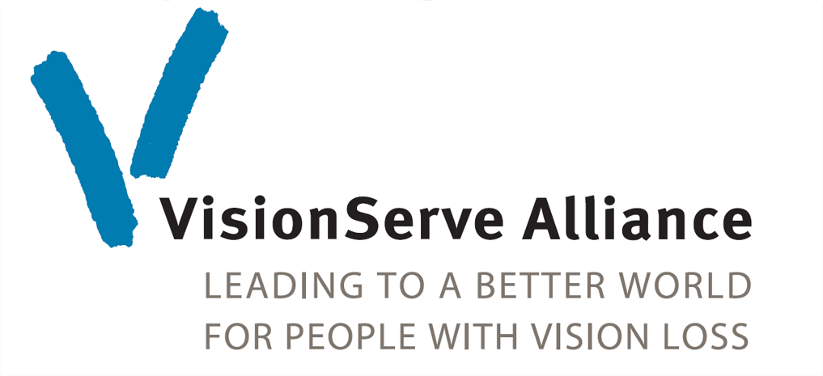

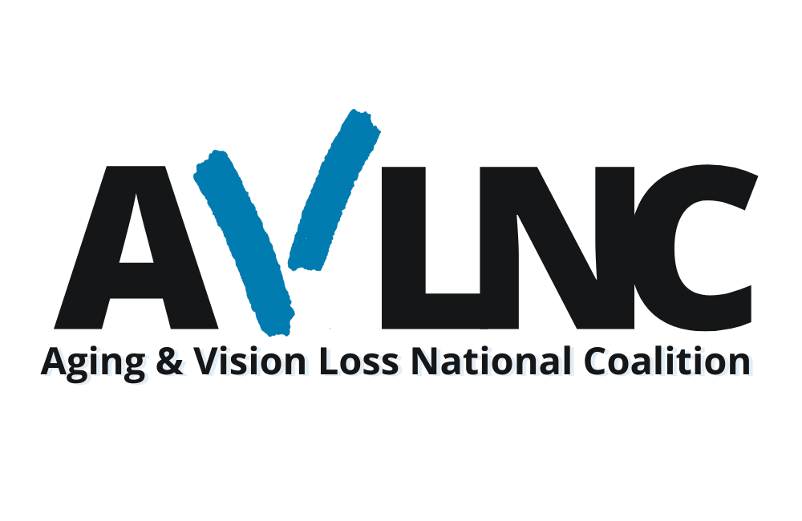

Table of Contents
1. Executive Summary 3
2. Introduction 3
3. Scope of Vision Loss in United States Aging population 4
Prevalence 4
Geographic Distribution 5
Co-Occurring Conditions 6
Health Related Quality of Life 7
Diabetes and Vision Loss 8
4.Vision Rehabilitation 10
Vision Rehabilitation Network 11
Vision Rehabilitation Works 12
6. Conclusion 14
7. References 15

Preferred Citation: VisionServe Alliance. Vision Impairment and Vision Rehabilitation in the Lives of Older People with Vision Loss. November 2020, St. Louis.

1. Executive Summary
Vision loss is a pervasive, potentially devastating problem among older people. Research has shown that at least half of Americans aged 65 and older are at high risk of eye diseases that can lead to impaired sight. As our population ages, the number of older people experiencing vision loss will grow exponentially. Women, minorities, and older people living in rural areas are at higher risk of experiencing vision loss and will be increasingly and disproportionately affected by visual impairment. Further, older people with vision loss experience higher rates of diabetes, falls, hearing loss, frailty and even death.
With the proper services and supports, older people with vision loss can lead full, independent lives. Vision rehabilitation services can make a substantial impact on older people with vision loss- allowing them to remain safely independent in their homes, caring for themselves. Unfortunately, according to the National Health Interview Survey, only about 3% of older people with vision impairment receive rehabilitation services.¹ Currently the federal appropriation of $33 million for state and community-based agencies serves fewer than 60,000 people. An increase in federal funding is needed to meet the needs of this growing population.

2. Introduction
Visual impairment among older people represents a serious national public policy and public health concern. According to the CDC, “vision health is critically important for all aspects of a person’s life, including physical health, social engagement, education, employment, and socioeconomic position.”² As the population in the United States ages, the nation faces a significant challenge in adequately serving the needs of older individuals with vision impairment. This group is growing dramatically and faces a lack of access to essential rehabilitation services.
VisionServe Alliance is a collaborative association of service providers and key actors in the field of blindness whose goal is to engage leaders in building a better world through services to people with vision loss. VisionServe Alliance convened experts from across the country to create this policy brief which calls for a spotlight on vision loss within national priorities on aging and increased federal funding for vision rehabilitation services.
Between 2015 to 2050, the number of people 40 years and older who are blind or visually impaired is expected to double.³ Thus, the number of people requiring vision rehabilitation will likely increase in dramatic ways.

Facts About Vision Loss
- People with visual impairment are more likely to be poorer, less educated, and less likely to participate in the workforce.
- African American individuals experience the highest prevalence of visual impairment and blindness.
- Women are projected to outnumber men by 30% to 32% with respect to VI and by 6% to 11% with respect to blindness. (Varma)
- Older people with vision impairment are more likely to report age-related chronic conditions than their sighted peers. The prevalence of dual sensory impairment increases markedly with age with over 50% of people with vision loss 65 and older having hearing loss.
- Older people with vision impairment are twice as likely to fall compared to older people without vision impairment.

3. Scope of Vision Loss in United States Aging population

Prevalence
Estimates suggest that in the United States in 2015, there were 760,000 people over the age of 60 who are blind, 2.91 million people age 60 years who had vision impairment and another 8.2 million (age 40 and over) had vision impairment due to uncorrected refractive error. By 2050 these population estimates are expected to increase to 1.73 million people who are blind, 6.57 million people with vision impairment, and 16.4 million (over age 40) who have uncorrected refractive error.³ Other studies show that 5.7 million people age 65 years and older report “difficulty seeing even when wearing glasses.⁴ Among older people experiencing vision problems, they are more likely to be women and African American or Hispanic. They are also more likely to be poorer, less educated, have less access to medical and eye care, and have greater risk of mortality.
Individuals living in rural communities are often more impacted by vision loss. Vision loss compounds challenges related to access to transportation as well as other supportive services. It is often more difficult to receive healthcare services in general, and specifically specialized services like vision rehabilitation in rural settings. In addition, access to critical assistive technology services may also be limited for individuals in rural settings.

Geographic Distribution
Vision impairment among older people is not distributed evenly over the United States. Some counties and regions of the nation have higher prevalence of vision impairment than others. Vision impairment is especially prevalent in areas that are poorer and where access to medical and eye care is limited.
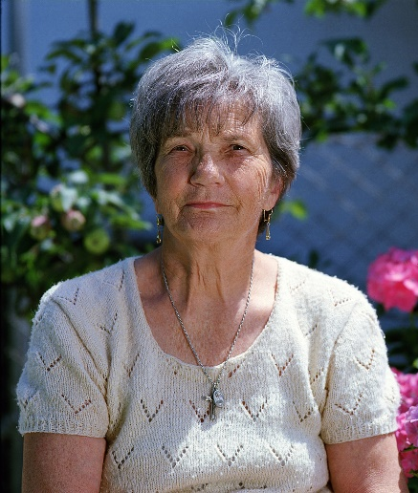
Meet Ann
Ann experienced both progressive vision and hearing loss as she aged. She was having difficulty talking on the phone, reading her mail, cooking, and caring for herself. Working with a vision rehabilitation therapist, Ann received training and technology to overcome these obstacles. She learned how to use speed dial on her new amplified phone with large buttons. Ann also received a portable electronic magnifier and skills training to read her mail, identify food labels and cook independently. Through vision rehabilitation, Ann was able to regain her independence.

The national map below shows the prevalence of severe vision impairment (A positive response to the question: “Are you blind or do you have serious difficulty seeing?) by county. Counties identified with darker shading represent higher prevalence of vision problems. The map displays a higher concentration of counties with high prevalence of vision loss in Appalachia, the South, and the border counties in the Southwest regions of the United States.

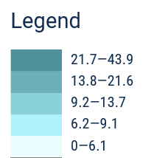
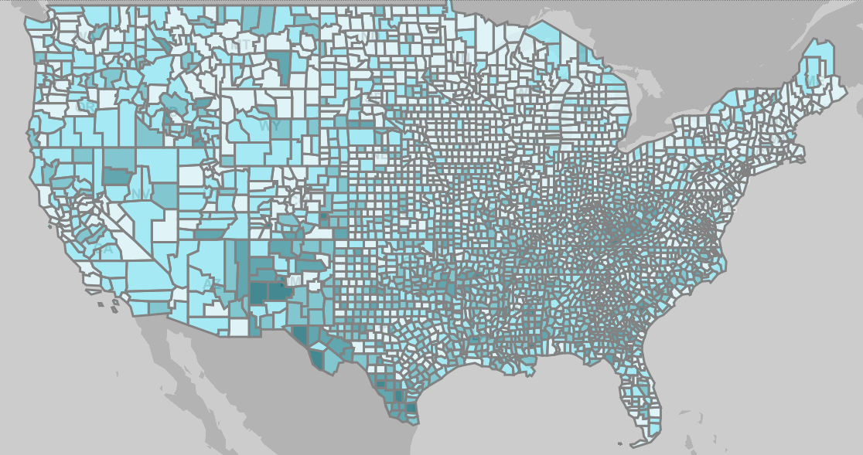
Prevalence of Vision Loss Across United States

Co-Occurring Conditions
Not only is the population of older people increasing in absolute numbers, but their circumstances suggest that they as a group present complex problems that must be addressed by providers, family members, and caregivers. In particular, older people with vision impairment are more likely to report poorer health in large part because they are more likely to report age-related chronic conditions compared to people without vision impairment. People with vision impairment are about twice as likely to report stroke than older people without vision impairment (14.4% vs 7.1%) largely because stroke can cause vision loss. They are also more likely to report diabetes (28.4% vs. 19.5%) because diabetes leads to diabetic retinopathy. They are almost twice as likely to report depression and twice as likely to report falls than older people without vision loss. The impact of multiple chronic conditions is that older people with vision impairment are almost twice as likely (43% vs 23%) to report poor health.^{5,6}

Health Related Quality of Life
Health-related quality of life assesses life dissatisfaction, health, number of physically and mentally unhealthy days in the past month, and limited activity in the past month. Older people with vision impairments report worse outcomes in each health-related quality of life indicator compared to older people without vision impairment, illustrated in the graph below. Furthermore, the severity of the vision loss is associated with poorer outcomes.⁷ Vision rehabilitation has the potential to have impact on health related quality of life by helping people gain the skills to travel their communities independently to reconnect with peers and loved ones as well as connect with important resources to manage and address health concerns.

Diabetes and Vision Loss
Diabetic retinopathy is a retinal vascular disorder that occurs as a complication of diabetes mellitus and is the leading cause of vision impairment in the US, affecting 4.1 million people. One in every twelve people who has diabetes mellitus has advanced, vision threatening retinopathy.⁸

Meet Steven
At age 58, Steven became totally blind due to diabetes-related retinopathy. He was overwhelmed by his circumstances until he received vision rehabilitation. His vision rehab therapist was able to provide him with important health monitoring equipment, including: a talking blood pressure monitor, a talking scale and a talking blood glucose meter. Steven also received training from a diabetes educator so he learned to independently monitor his blood sugar levels and other health markers to better control his diabetes. Now, Steven can independently identify his different medications and verify when and how to take each one without assistance, effectively managing his disease and taking charge of his life.

The below map shows the prevalence of diabetic retinopathy rates by state in the United States, with the highest concentration along the southwest coast including Texas, New Mexico, Arizona, and California. Also included in the highest concentration rates are New York and Florida.
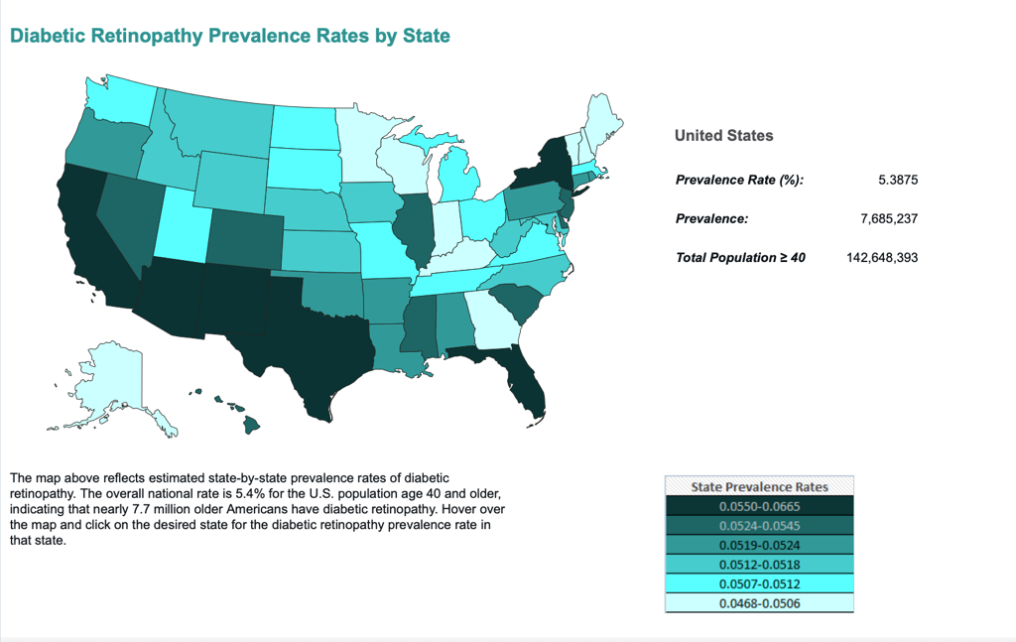
People with diabetic eye disease need to be able to monitor their blood glucose levels, keep track of medications, take insulin accurately, prepare healthy foods and manage portion control, manage proper foot care, keep track of their weight, set up appropriate exercise routines, and take care of a myriad of other daily tasks needed to live independently. Vision rehabilitation helps people with diabetic retinopathy manage both their vision loss and their diabetes. Vision rehabilitation professionals provide training in how to manage these critical tasks as well as refer to diabetes educators who can help with self-management and connect the person with other resources.

4.Vision Rehabilitation
Vision Impairment often compromises multiple aspects of everyday life including the ability to manage one’s home, keep up with finances, take appropriate medications, and travel the community. Vision Impairment often results in social isolation and diminishes interactions with family, friends, and work colleagues, and it can limit participation in community events.
Vision rehabilitation often combats these factors by providing people with vision impairment the tools to live independently. Specialized vision rehabilitation professionals help individuals who are blind or visually impaired attain increased function, well-being, personally satisfying levels of independence, and improved quality of life. Vision rehabilitation services are an essential piece of the puzzle to addressing the impacts of vision loss on the safety and independence of older people.
Guided by best practices from the field and the Older Individuals who are Blind Technical Assistance Center (OIB-TAC), vision rehabilitation professionals can address a wide range of needs for individuals with vision loss. The areas range from learning how to access print to safely navigating the environment to mastering new strategies to engage in recreational activities enhancing quality of life. The importance and effectiveness of these services is endorsed by the American Academy of Ophthalmology as the standard of care.
Addressing vision loss can also reduce other health concerns. According to the National Institute on Aging, 1 out of 3 older people over 65 falls.⁷ Vision rehabilitation provides older people with the tools to navigate their environments safely, an important component of fall prevention. Furthermore, vision rehabilitation can reduce frailty and risk of mortality by encouraging physical activity and interventions that encourage independent activities of daily living.

Vision Rehabilitation Network
Vision rehabilitation services are offered nationally through special funding under Title VII of the Rehabilitation Act, as amended--the Independent Living Services for Older Individuals who are Blind program (OIB). A total of $33 million is divided among state agencies serving people with vision loss and requires a 10% state match. The percentage of funding each state receives is based on the number of older people in the state in relation to the number nationally. This formula allows one-third of the states to receive only $225,000.
Vision Rehabilitation Professionals
- Vision Rehabilitation Therapists teach adaptive independent living skills, enabling adults with vision loss to confidently carry out a range of daily activities.
- Orientation and Mobility Specialists teach the skills that people with vision loss need to travel independently and safely in the home and in the community. including the use of a long cane, electronic travel devices, public transportation, and human guide.
- Low Vision Therapists instruct individuals with low vision in the efficient use of remaining vision with optical devices, non-optical devices, and assistive technology, and can help determine the need for environmental modifications in the home.
- Assistive Technology Instructional Specialists teach the use of assistive technology to carry out everyday tasks. For individuals who are blind or have low vision, assistive technology refers to any adaptive device or software program that helps to overcome the barriers presented by vision loss.
In addition, vision rehabilitation services are provided by private agencies serving people with vision loss. Some agencies contract with the states through the OIB program. Others use donations, local, state, and other funds to provide services in their communities.
The level of funding at the national level has remained static for more than a decade, and has not kept pace with the demand for vision rehabilitation services. Currently the federal appropriation serves fewer than 60,000 people, whereas the latest estimates show that there are over four million people aged sixty and older who are blind or visually impaired.³

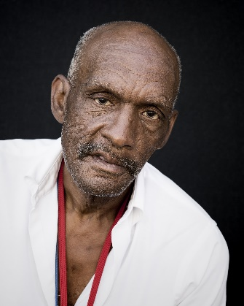
Meet Alex
Alex is a retired school teacher who recently became legally blind. He lives in an area without family close by and before receiving vision rehabilitation, his life had significantly deteriorated. His clothes were soiled, he needed a haircut and a shave and ate frozen food for most of his meals. Through vision rehabilitation, Alex learned non-visual techniques for preparing food, cleaning his apartment and doing his laundry. He learned the skills he needed to regain his ability to travel outside of his apartment to go shopping or get a haircut. Vision rehabilitation transformed Alex’s life, allowing him to regain his independence and reconnect with his community.

Vision Rehabilitation Works
Studies have shown the value and importance of vision rehab for individuals with vision loss. Demonstrated gains in mobility, activity, and independence have been proven in wide-ranging studies across the country. Furthermore, first-hand accounts from older people who have benefitted from vision rehabilitation services as moving testaments to the power of these services to change lives.

Making Eye Health a Population Health Imperative: Vision for Tomorrow
“Vision rehabilitation helps improve health and visual functioning for patients in numerous age groups and with different degrees and causes of vision impairment.”
National Academies of Science, Engineering and Medicine (NASEM) 2016
Impact Study
Participants in the study showed significantly less functional disability (using Functional Vision Scale) and reported they were able to do more activities such as reading, writing, cooking, playing cards, etc., after receiving of vision rehabilitation services. Participants also showed a reduction in depression scores and increased psychological ability to adapt to vision loss (Lavelle, 2005).
VISIONS, a vision rehabilitation agency, New York City, 2003
The Georgia Report
Among participants who had received daily living skills training, 61% of respondents reported they could function more independently while 40% had maintained their ability. Fifty-six percent of the 340 individuals responding reported they had greater control and confidence in their ability to maintain their current living situation after vision rehabilitation services.
Mississippi State University National Research and Training Center on Blindness and Low Vision.
Expert Testimony
“Randomized controlled studies have demonstrated the efficacy of both inpatient and outpatient vision rehabilitation services. For people with chronic vision loss that can’t be corrected with surgery or refraction, the evidence tells us that vision rehabilitation improves overall independence and performance on specific visually mediated tasks, including mobility and reading. A recent study even found that visually impaired Veterans with mild to moderate cognitive deficits experienced functional improvements after participating in outpatient vision rehabilitation programs.”
Heather E. Whitson, MD, MHS
Director, Duke Center for the Study of Aging and Human Development
Duke University School of Medicine & Durham VA Medical Center

Firsthand Testimony
“They helped me to do my cooking and baking safely. They gave me confidence to not be isolated in my home, to be able to go out again, and have confidence to accept my disability.”
Project evaluation report: Project Independence, Georgia Vision Program (2017)

Caregiver Testimony
“Vision rehab literally brought my 92-year-old mother to tears of relief and gratitude. She could write personal cards, continue to cook her breakfast and maneuver steps safely to be confident to live independently, inside and out.”
Mary Worstell

6. Conclusion
Access to vision rehabilitation is critical in preserving the ability of older people with visual impairments to live with greater independence and improved opportunities to participate in their communities. Vision rehabilitation provides tools and techniques to achieve these goals. Across the United States, vision rehabilitation agencies experience inconsistent funding and, often, are very minimally supported by any level of government, leading to a unstable reliance on private grants and donations to provide services that fill the most basic rehabilitation needs for this population.
Older people with vision loss should have the training and resources to successfully age in place and engage in meaningful activities in their homes and in their communities. Our nation can ensure this as a reality by substantially increasing federal funding to the nation’s vision rehabilitation infrastructure.

7. References

¹Healthy People 2020 Vision Objectives. https://www.healthypeople.gov/2020/topics-objectives/topic/vision/objectives
²https://www.cdc.gov/visionhealth/programs/vision-toolkit.html
³Varma, R., Vajaranant, T.S., Burkemper, B., Wu, S., Torres, M., Hsu, C., Choudhury, F. and McKean-Cowdin, R., 2016. Visual impairment and blindness in adults in the United States: demographic and geographic variations from 2015 to 2050. JAMA ophthalmology, 134(7), pp.802-809.
⁴Crews, J.E., Jones, G.C. and Kim, J.H., 2006. Double jeopardy: the effects of comorbid conditions among older people with vision loss. Journal of Visual Impairment & Blindness, 100(1_suppl), pp.824-848.
⁵Crews, J. E., Chou, C. F., Sekar, S., & Saaddine, J. B. (2017). The prevalence of chronic conditions and poor health among people with and without vision impairment, aged≥ 65 years, 2010–2014. American journal of ophthalmology, 182, 18-30.
⁶Crews, J. E., Chou, C. F., Stevens, J. A., & Saaddine, J. B. (2016). Falls among persons aged≥ 65 years with and without severe vision impairment—United States, 2014. Morbidity and Mortality Weekly Report, 65(17), 433-437.
⁷Crews, J. E., Chou, C. F., Zhang, X., Zack, M. M., & Saaddine, J. B. (2014). Health-related quality of life among people aged≥ 65 years with self-reported visual impairment: Findings from the 2006–2010 behavioral risk factor surveillance system. Ophthalmic epidemiology, 21(5), 287-296.
⁸Kempen, J.H., O'Colmain, B.J., Leske, M.C., Haffner, S.M., Klein, R., Moss, S.E., Taylor, H.R., Hamman, R.F., West, S.K., Wang, J.J. and Congdon, N.G., 2004. The prevalence of diabetic retinopathy among people in the United States. Archives of ophthalmology, 122(4), pp.552-563.

https://www.oib-tac.org/sites/www.oib-tac.org/files/Older%20Blind%20Policy%20Brief.pdf

