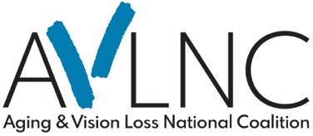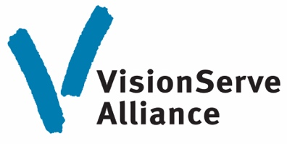

Big Data Project Reports - Vision Loss Among Adults 65+

Data based on American Community Survey and BRFSS survey question:
Are you blind or do you have serious difficulty seeing, even when wearing glasses?
- National: Yes = 4 million (7.3%)
- Tennessee: Yes = 106,000 (9%)
- Kentucky: Yes = 73,502 (9.7%)
- Ohio: Yes = 128,278 (6.6%)

Prevalence Range by County
- National = 4.8% – 43.2%
- Tennessee = 2.6% - 21.7%
- Kentucky = 3.3% - 23.5%
- Ohio = 3.4% - 12%

Less than High School Degree
- National: 28.7% < HS
- Tennessee: 37% < HS
- Kentucky: 31% < HS
- Ohio: 28% < HS

Income Under $10,000
- National: 10.6% income <$10K
- Tennessee: 9% Income <$10K
- Kentucky: 13.5% income <10K
- Ohio: 7% Income <$10K

Access to Health Care
- National = 11.5% delay due to cost
- Tennessee = 13.2% delay due to cost
- Kentucky = 7.6% delay due to cost
- Ohio = 14% delay due to cost

Chronic Conditions

Diabetes:
- National = 36%
- Tennessee = 44%
- Kentucky = 32%
- Ohio = 40%

Hearing Impairment:
- National = 33%
- Tennessee = 44%
- Kentucky = 38%
- Ohio = 30%

Depression:
- National = 27%
- Tennessee = 32%
- Kentucky = 21%
- Ohio = 26%

Stroke:
- National = 17%
- Tennessee = 20%
- Kentucky = 17%
- Ohio = 19%

Fair-Poor Health:
- National = 51%
- Tennessee = 60%
- Kentucky = 48%
- Ohio = 44%

Falls:
- National = 47%
- Tennessee = 49%
- Kentucky = 46%
- Ohio = 51%

Current Big Data Project 65+ Reports Available
Alabama, Arkansas, California, Colorado, Florida, Georgia, Illinois, Indiana, Kansas, Kentucky, Louisiana, Michigan, Nebraska, New Hampshire, New Jersey, New York, North
Carolina, Ohio, Oklahoma, Oregon, Pennsylvania, South Carolina, Tennessee, Texas, Washington, Wisconsin and the NATIONAL REPORT.

Big Data Project 65+ Reports are Free to Download
Access reports, details, additional analyses, and links to webinars at VisionServe Alliance Big Data Report

Don’t See Your State Report?
Contact Helen Chapman at HChapman@VisionServeAlliance.org

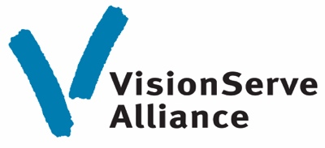

VisionServeAlliance.org

