
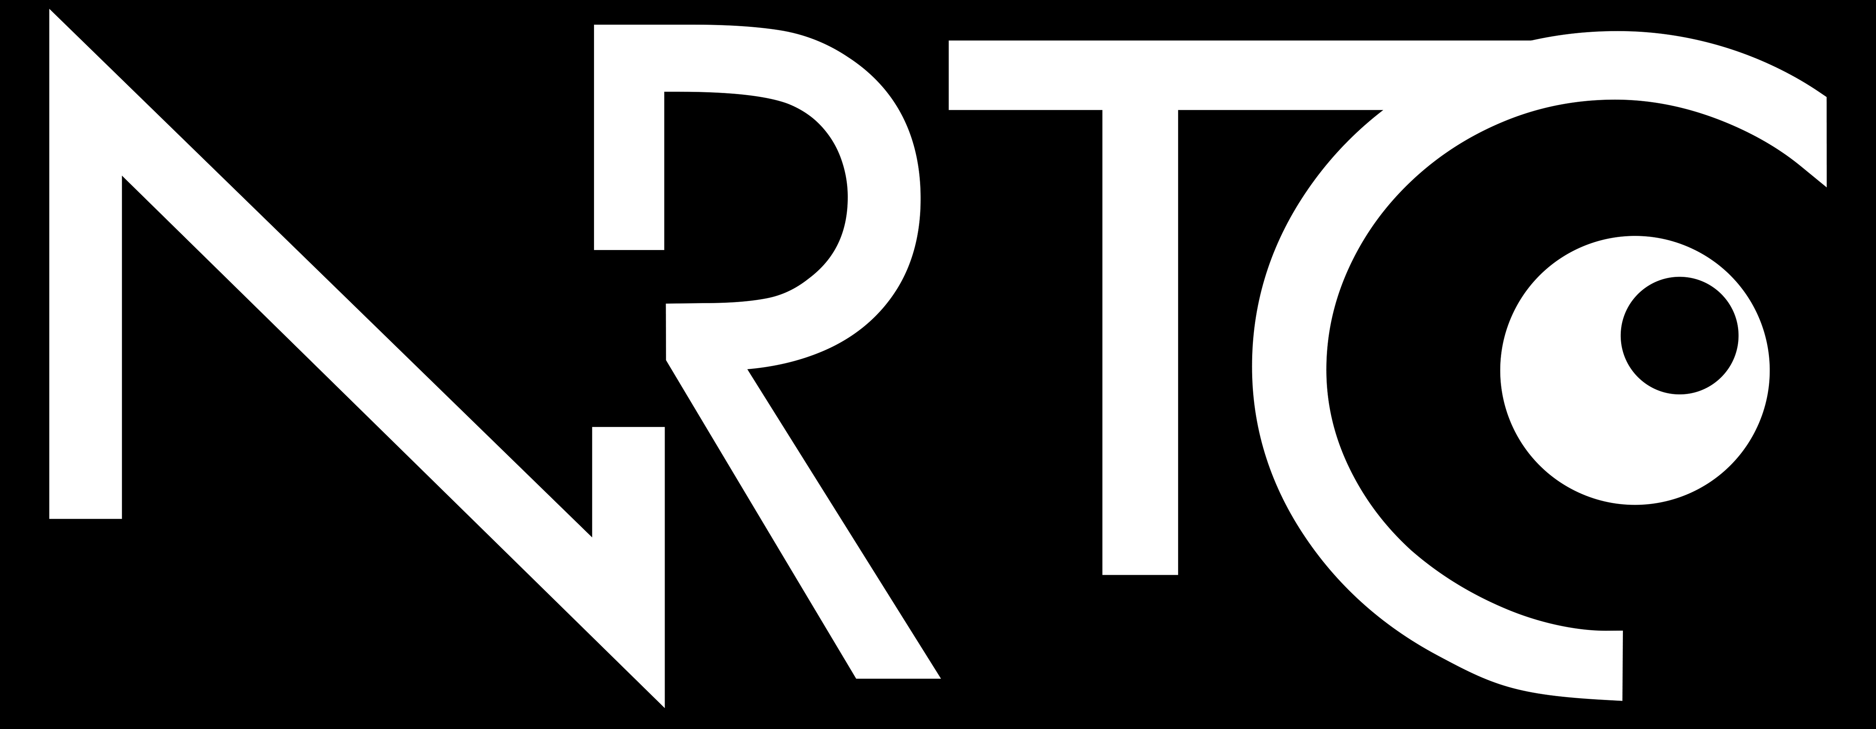
Employment Statistics for Adults with Visual Impairments: Definitions and Calculations
NRTCFACT SHEET
This fact sheet provides definitions, formulas, and calculations for the employment rate, unemployment rate, and labor force non-participation rate. It focuses on working-age adults with visual impairments in the United States using data from the 2023 American Community Survey.

Key Terms
- Employed: People who are currently working.
- Unemployed: People who are not working but are available for work and actively seeking work.
- Not in the Labor Force: People who are not working and not seeking work. This group may include retired people, students, homemakers, and other people who did not actively look for work in the previous 4 weeks.
- Civilian Noninstitutionalized Population: People who are not in the military and not living in institutions such as prisons and nursing homes.
- Civilian Labor Force: All people who are either working or actively looking for work.

Employment Rate
Definition: The percentage of people in the civilian noninstitutionalized population who are employed.
Formula:
$$\left(\frac{Employed}{Civilian Noninstitutionalized Population }\right)x 100$$
Employment rate for adults with visual impairments:
$$\left(\frac{2,238,272}{4,278,519 }\right)x 100=52.3\%$$

In 2023, 52.3% of working-age adults with visual impairments were employed, compared to 76.3% of the general population.

Unemployment Rate
Definition: The percentage of people in the civilian labor force who are unemployed.
Formula:
$$\left(\frac{Unemployed}{Civilian Labor Force }\right)x 100$$
Unemployment rate for adults with visual impairments:
$$\left(\frac{196,072 }{2,434,344 }\right)x 100=8.1\%$$
In 2023, 8.1% of working-age adults with visual impairments were unemployed, compared to 4.2% of the general population.

Labor Force Non-Participation Rate
Definition: The percentage of people in the civilian noninstitutionalized population who are not in the labor force.
Formula:
$$\left(\frac{Not in Labor Force}{Civilian Noninstitutionalized Population }\right)x 100$$
Labor force non-participation rate for adults with visual impairments:
$$\left(\frac{1,844,175}{4,278,519 }\right)x 100=43.1\%$$
In 2023, 43.1% of working-age adults with visual impairments were not in the labor force, compared to 20.4% of the general population.

Why don’t these percentages add up to 100%?
The percentages don’t add up to 100% because they are based on different groups of people.
- The employment rate and labor force non-participation rate focus on everyone in the civilian noninstitutionalized population, including people who are working, actively looking for work, and not working and not seeking work.
- The unemployment rate only focuses on people in the labor force, including people who are either working or actively looking for work. It does not include people who are not working and not seeking work.
Because these calculations focus on different groups, they cannot be combined to equal 100%. The unemployment rate uses a smaller group (the labor force) as its denominator, so it’s not directly comparable to the employment and labor force non-participation rates, which use the entire population.
Source: Data from the U.S. Census Bureau, 2023 American Community Survey 1-year estimates, people with visual impairments (ages 18–64) in the U.S. civilian noninstitutionalized population.


The contents of this document were developed under a grant from the U.S. Department of Health and Human Services, NIDILRR grant 90RTEM0007. However, these contents do not necessarily represent the policy of the Department of
The contents of this document were developed under a grant from the U.S. Department of Health and Human Services, NIDILRR grant 90RTEM0007. However, these contents do not necessarily represent the policy of the Department of Health and Human Services and should not indicate endorsement by the Federal Government.
662-325-2001

nrtc@colled.msstate.edu

