

Aug. 24, 2026
Letters: Head Start makes a difference for children
Print and Online:
https://www.chicagotribune.com/2026/08/25/letters-082526-head-start/
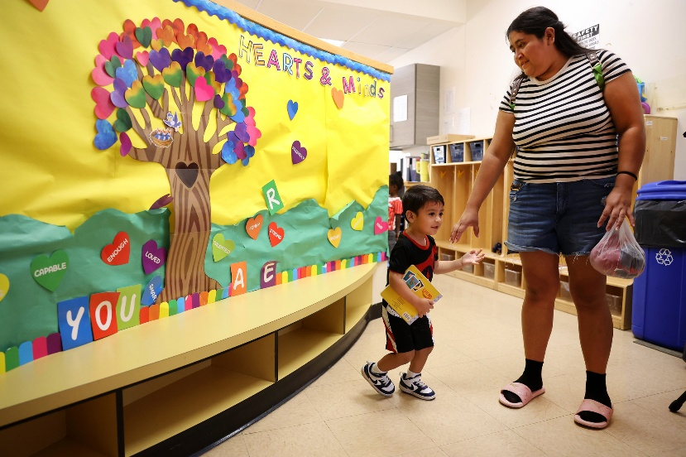
The Aug. 10 article “Trump deregulation plan vexes Head Start providers” raises important questions about proposed changes to Head Start and what they could mean for children and families across Illinois and the country. I am particularly concerned about what these changes could mean for the health screenings that are a critical part of Head Start and its commitment to the health, development and school readiness of children from families with lower incomes.
Early childhood is a critical time for vision development. Identifying a problem and connecting a child to care can mean the difference between the child seeing clearly in the classroom and struggling to learn.
Research has found that approximately 1 in 5 Head Start preschoolers have a vision disorder. Current Head Start standards require evidence-based vision screening within 45 days of a child’s first day in the program, with appropriate referral for follow-up vision care when a potential vision problem is identified. The proposed changes would loosen those requirements, allowing greater variation in how and when children are screened.
That may sound like regulatory flexibility, but it risks creating even greater inconsistency among programs and could result in children receiving screenings that do not follow evidence-informed guidelines.
Through our National Center for Children’s Vision and Eye Health, we train the professionals at Head Start programs across the country. Through this work, we have seen the difference vision screening can make in a child’s life. One program shared the story of a toddler whose screening identified astigmatism in both eyes, leading to an eye exam and glasses. Another reported that eight children referred for eye care following vision screenings received no-cost exams and glasses, with families reporting improvements in their learning. These screenings are working.
Yes, states and communities should have flexibility to meet the needs of their children. But flexibility should not come at the expense of evidence-based standards that we know help children thrive. Illinois children — and children everywhere — deserve the same opportunity for a healthy start, regardless of their family’s income or where they happen to live.
— Jeff Todd, president and CEO, Prevent Blindness, Chicago

